UNITED STATES
SECURITIES AND EXCHANGE COMMISSION
Washington, D.C. 20549
FORM 8-K
CURRENT REPORT
Pursuant to Section 13 OR 15(d) of The Securities Exchange Act of 1934

Date of Report (Date of earliest event reported): October 15, 2026

KRYSTAL BIOTECH, INC.
(Exact name of registrant as specified in its charter)

Delaware |  |  |  |  |  | 001-38210 |  |  |  |  |  | 82-1080209
(State or other jurisdiction  of incorporation) |  |  |  |  |  | (Commission  File Number) |  |  |  |  |  | (IRS Employer  Identification No.)

 |  |  | 2100 Wharton Street, Suite 701 |  |  |  |  |  |  |  |  | 15203
 |  |  | Pittsburgh, |  |  | Pennsylvania
 |  |  | (Address of principal executive offices) |  |  |  |  |  |  |  |  | (Zip Code)

Registrant’s telephone number, including area code (412) 586-5830
Check the appropriate box below if the Form 8-K filing is intended to simultaneously satisfy the filing obligation of the registrant under any of the following provisions:
☐ |  |  | Written communications pursuant to Rule 425 under the Securities Act (17 CFR 230.425)
☐ |  |  | Soliciting material pursuant to Rule 14a-12 under the Exchange Act (17 CFR 240.14a-12)
☐ |  |  | Pre-commencement communications pursuant to Rule 14d-2(b) under the Exchange Act (17 CFR 240.14d-2(b))
☐ |  |  | Pre-commencement communications pursuant to Rule 13e-4(c) under the Exchange Act (17 CFR 240.13e-4(c))

Securities registered pursuant to Section 12(b) of the Act:

Title of each class |  |  |  |  |  | Trading Symbol(s) |  |  |  |  |  | Name of each exchange on which registered
Common Stock |  |  |  |  |  | KRYS |  |  |  |  |  | Nasdaq Global Select Market
Indicate by check mark whether the registrant is an emerging growth company as defined in Rule 405 of the Securities Act of 1933 (§230.405 of this chapter) or Rule 12b-2 of the Securities Exchange Act of 1934 (§240.12b-2 of this chapter).
Emerging growth company ☐
If an emerging growth company, indicate by check mark if the registrant has elected not to use the extended transition
period for complying with any new or revised financial accounting standards provided pursuant to Section 13(a) of the
Exchange Act. ☐

Item 7.01 Regulation FD Disclosure.

On October 15, 2026, Krystal Biotech, Inc. (the “Company”) issued a press release announcing clinical data from its Gorlin Syndrome Pilot Study evaluating KB113 for the treatment of basal cell carcinomas in patients with Gorlin syndrome. The data will be presented by study investigator Shireen V. Guide, MD, in a poster entitled “Use of an HSV-1-Based Immunotherapy, KB113, to Treat Basal Cell Carcinoma in Patients with Gorlin Syndrome” at the 14th Pediatric Dermatology Research Alliance (PeDRA) Annual Conference, being held October 15–17, 2026 in Alexandria, Virginia. Copies of the press release and the poster are furnished as Exhibit 99.1 and Exhibit 99.2, respectively, to this Current Report on Form 8-K and are incorporated herein by reference. The press release and poster are also available on the “Investors” section of the Company's website at www.krystalbio.com.

The information in this Item 7.01 of this Current Report on Form 8-K, including Exhibits 99.1 and 99.2, shall not be deemed “filed” for purposes of Section 18 of the Securities Exchange Act of 1934, as amended (the “Exchange Act”), or otherwise subject to the liabilities of that Section, nor shall it be deemed incorporated by reference in any filing under the Securities Act of 1933, as amended, or the Exchange Act, except as shall be expressly set forth by specific reference in such filing.

Item 9.01 Financial Statements and Exhibits.

(d) Exhibits.
Exhibit  No. |  |  |  |  |  | Description
99.1 |  |  |  |  |  | Press Release of Krystal Biotech, Inc., dated October 15, 2026
99.2 |  |  |  |  |  | Poster entitled “Use of an HSV-1-Based Immunotherapy, KB113, to Treat Basal Cell Carcinoma in Patients with Gorlin Syndrome”
104 |  |  |  |  |  | Cover Page Interactive Data file (embedded within the Inline XBRL document)

SIGNATURES
Pursuant to the requirements of the Securities Exchange Act of 1934, the registrant has duly caused this report to be signed on its behalf by the undersigned hereunto duly authorized.

Date: October 15, 2026 |  |  |  |  |  |  |  |  |  |  |  | KRYSTAL BIOTECH, INC.
 |  |  |  |  |  |  |  |  |  |  |  | By: |  |  |  |  |  | /s/ Krish S. Krishnan
 |  |  |  |  |  |  |  |  |  |  |  | Name: |  |  |  |  |  | Krish S. Krishnan
 |  |  |  |  |  |  |  |  |  |  |  | Title: |  |  |  |  |  | Chairman and Chief Executive Officer

Exhibit 99.1
Krystal Biotech Announces Positive Clinical Data for New
Dermatology Program KB113 Demonstrating Broad Basal Cell Carcinoma Regression in Patients with Gorlin Syndrome

Over 80% of assessed basal cell carcinoma lesions regressed across three Gorlin syndrome patients treated with KB113

Substantial regression was observed in lesions not directly injected with KB113, consistent with abscopal effect

KB113 injections were well tolerated by Gorlin syndrome patients; all reported adverse events were mild to moderate in severity and transient in nature

Data will be presented by study investigator Dr. Shireen Guide at the 14th PeDRA Annual Conference, October 15-17, 2026

PITTSBURGH, October 15, 2026 (GLOBE NEWSWIRE) – Krystal Biotech, Inc. (the “Company”) (NASDAQ: KRYS) announced today a positive clinical update supporting initial proof of concept for KB113, an intratumoral immunotherapy designed to drive sustained, localized expression of interleukin-2 (IL-2) and interleukin-12 (IL-12) in the tumor microenvironment and promote systemic immune-mediated tumor clearance, in the treatment of basal cell carcinomas (BCCs) in patients with Gorlin syndrome:

•Broad antitumor responses were detected in all three Gorlin syndrome patients treated with KB113, with over 80% of assessed BCC lesions reducing in size;
•Responses were observed in both injected and non-injected lesions, including substantial regression in lesions that were not directly injected with KB113, consistent with an abscopal effect; and
•Complete clearance of an injected lesion was also confirmed histologically for each of the three patients treated with KB113.

Gorlin syndrome is a genetic disease characterized by a greatly increased risk of developing BCCs. Patients with Gorlin syndrome can develop BCCs as early as infancy and may have hundreds of BCCs over their lifetimes requiring frequent and potentially disfiguring surgical procedures. The psychological and physical toll of Gorlin syndrome builds over time, as patients are subjected to repeated cycles of surveillance, surgery, and recovery to manage emergent BCCs, with each surgery adding to the cumulative risk of scarring and permanent tissue loss. Prevalence data for Gorlin syndrome is limited but available data suggest the number of patients with Gorlin syndrome in the United States could exceed 10,000.

“For individuals living with Gorlin syndrome, the lifelong emergence of multiple BCCs creates an immense cumulative treatment burden—often resulting in extensive scarring and significant impacts on quality of life,” said Shireen V. Guide, MD, Mission Dermatology Center. “The observed antitumor responses with KB113 across both injected and non-injected lesions represent encouraging preliminary findings that strongly support its continued clinical development.”

Gorlin Syndrome Pilot Study Clinical Results

KB113 is the low dose of intratumoral KB707 that showed promising early efficacy signals in patients with BCC in the Company’s OPAL-1 Phase 1/2 study, an open label, multicenter, dose escalation and expansion Phase 1/2 study in patients with injection-accessible solid tumors. The Gorlin Syndrome Pilot Study was a multicenter, single-arm, open label study designed to evaluate the safety and preliminary efficacy of KB113 for the treatment of BCCs in patients with Gorlin syndrome. Three adult patients with Gorlin syndrome were enrolled in the study. All three patients received six doses of up to 2 mL of 108 PFU/mL KB113 over a period of 14 weeks, with the first two doses spaced two weeks apart followed by dosing once every three weeks. Landmark lesions, defined as facial BCCs ≥5 mm in diameter or non-facial BCCs ≥9 mm in diameter, were identified by the investigator and visually assessed for clinical regression throughout the 14-week treatment period and again 30 days after the final dose using a pre-specified, investigator-assessed 5-point clearance scale. The scale categorizes each lesion by magnitude of regression. Only landmark lesions were eligible for injection with KB113. The investigator selected which landmark lesions to inject, irrespective of anatomical location, and determined the injection volume for each lesion based on its clinical presentation. Additional details on the OPAL-1 study can be found at www.clinicaltrials.gov under NCT identifier: NCT05970497.

Regression of landmark lesions was observed as early as two weeks after initiation of treatment, with responses broadening and deepening over time. At the final assessment conducted 30 days after last dose, over 80% of all assessed landmark lesions had regressed. Over half of all landmark lesions demonstrated greater than 50% clinical regression, and a subset demonstrated at least 90% clinical regression, as assessed using the investigator-assessed 5-point clearance scale. Substantial regression was observed in lesions that had never been directly injected, providing preliminary evidence of an abscopal effect.

Details on response rates at the final assessment are summarized below:

Combined Results for All Three Gorlin Syndrome Patients

Clinical Regression |  |  | Injected |  |  | Non-Injected |  |  | Overall
Any clinical regression in lesion size* |  |  | 29/36 (80.6%) |  |  | 40/47 (85.1%) |  |  | 69/83 (83.1%)
> 50% clinical regression** |  |  | 15/36 (41.7%) |  |  | 27/47 (57.4%) |  |  | 42/83 (50.6%)
≥ 90% clinical regression |  |  | 4/36 (11.1%) |  |  | 4/47 (8.5%) |  |  | 8/83 (9.6%)
* Inclusive of lesions with > 50% clinical regression
** Inclusive of lesions with ≥ 90% clinical regression

To further assess clinical regression, one injected lesion from each patient that had achieved at least 90% clinical regression was biopsied. All three biopsied lesions demonstrated histologically confirmed complete response, with no evidence of residual tumor tissue.

Consistent with prior experience in the low dose escalation cohort of OPAL-1, KB113 was well tolerated by all three patients enrolled in the Gorlin Syndrome Pilot Study. All reported adverse events were mild or moderate in severity, transient, and resolved during the study.

“The breadth and depth of responses reported today on landmark lesions located in various parts of the patient’s body showcase the systemic immune-activating potential of HSV-1 encoded IL-2 and IL-12 and have exciting implications for Krystal and the many patients we aim to serve,” said Suma Krishnan, President of Research and Development at Krystal Biotech. “Leveraging our extensive HSV-1 dataset and clinical experience, we believe there is an opportunity to quickly advance our newly announced program for Gorlin syndrome and further our commitment to patients suffering from skin diseases.”

The Company has initiated discussions with the United States Food and Drug Administration (FDA) regarding the advanced clinical development of KB113 for the treatment of Gorlin syndrome. The Company will provide an update on its clinical development plans following alignment with the FDA.

A poster summarizing the Gorlin Syndrome Pilot Study results will be presented by study investigator Dr. Guide at the 14th Pediatric Dermatology Research Alliance (PeDRA) Annual Conference, October 15-17, 2026 in Alexandria, Virginia. The poster is available to view online on the Investor section of the Company’s website.

About Krystal Biotech, Inc.
Krystal Biotech, Inc. (NASDAQ: KRYS) is a fully integrated, commercial-stage, global biotechnology company focused on the discovery, development and commercialization of genetic medicines to treat diseases with high unmet medical needs. VYJUVEK®, the Company’s first commercial product, is the first-ever redosable gene therapy and the first genetic medicine approved in the United States, Europe, and Japan for the treatment of dystrophic epidermolysis

bullosa. The Company is rapidly advancing a robust preclinical and clinical pipeline of investigational genetic medicines. Krystal Biotech is headquartered in Pittsburgh, Pennsylvania. Visit www.krystalbio.com to learn more or follow us on LinkedIn and X.

Forward-Looking Statements and Disclosures
This press release contains “forward looking” statements within the meaning of the Private Securities Litigation Reform Act of 1995 based on the Company’s current expectations and beliefs regarding its product candidate, KB113, for the treatment of patients with Gorlin syndrome. These forward-looking statements include, without limitation, statements relating to the systemic immune-activating potential of KB113; the potential of KB113 as a treatment for Gorlin syndrome; the Company’s plans to continue development of KB113 and its discussions with the FDA regarding the clinical development of KB113; an opportunity to quickly advance the KB113 program for Gorlin syndrome; and the Company’s plans to provide an update on its clinical development plans for KB113 following alignment with the FDA. All statements other than historical facts are or may be deemed to be forward-looking statements and involve known and unknown risks, uncertainties, and assumptions that could cause actual results to differ materially from those indicated by such forward-looking statements as a result of various important factors, including uncertainties inherent in the initiation and conduct of clinical trials and in regulatory review of clinical trials and applications for marketing approvals; whether results of early clinical trials, including results observed in a small number of patients, will be indicative of the results of later-stage studies; and such other important factors as are set forth under the caption “Risk Factors” in the Company’s annual and quarterly reports on file with the U.S. Securities and Exchange Commission. The Company provides this information as of the date of this press release and assumes no obligation to update any forward-looking statements.

KB113 is an investigational product candidate. The safety and efficacy of KB113 have not been established, and it has not been approved by the FDA or any other regulatory authority.

CONTACT
Investors and Media:
Stéphane Paquette, PhD
Krystal Biotech
spaquette@krystalbio.com
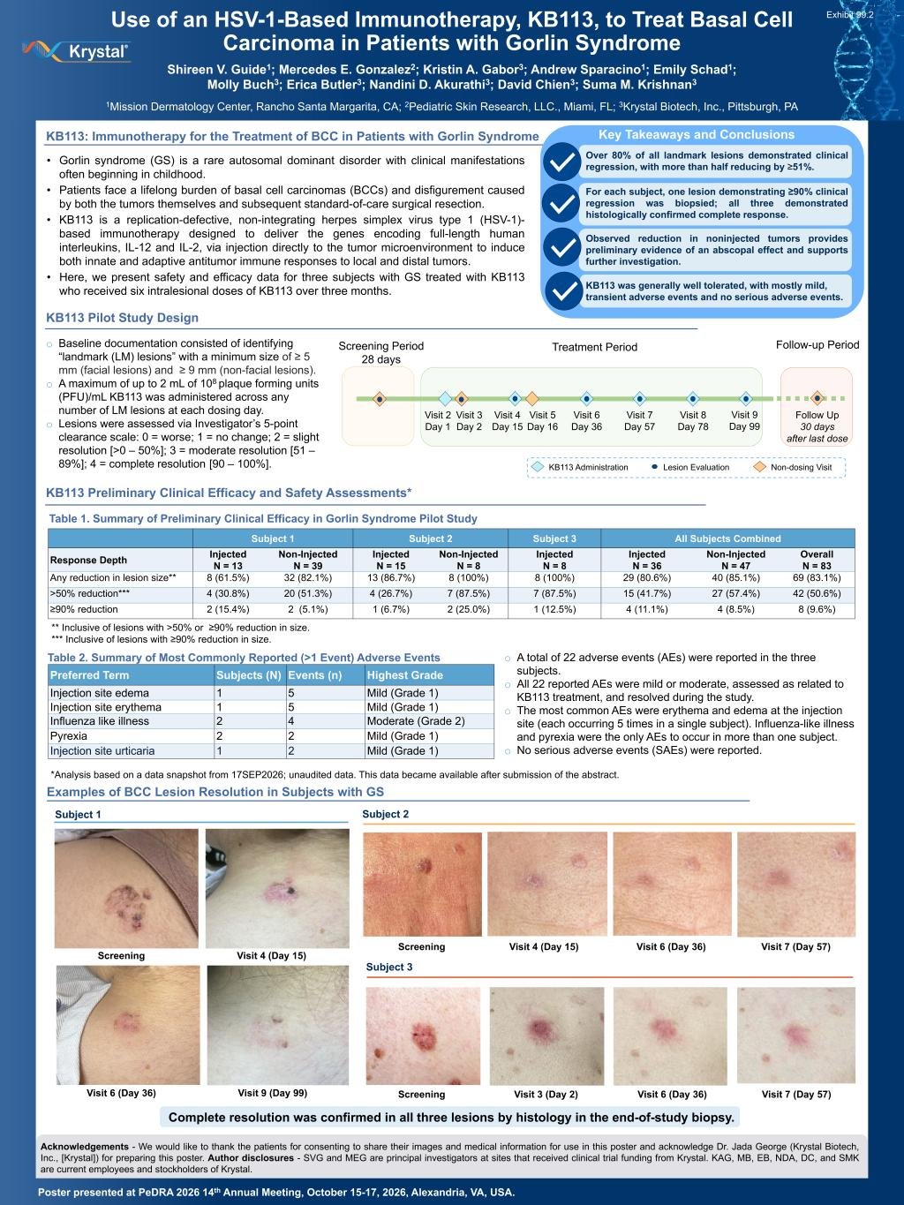

Use of an HSV-1-Based Immunotherapy, KB113, to Treat Basal Cell Carcinoma in Patients with Gorlin Syndrome Shireen V. Guide1; Mercedes E. Gonzalez2; Kristin A. Gabor3; Andrew Sparacino1; Emily Schad1; Molly Buch3; Erica Butler3; Nandini D. Akurathi3; David Chien3; Suma M. Krishnan3 1Mission Dermatology Center, Rancho Santa Margarita, CA; 2Pediatric Skin Research, LLC., Miami, FL; 3Krystal Biotech, Inc., Pittsburgh, PA Poster presented at PeDRA 2026 14th Annual Meeting, October 15-17, 2026, Alexandria, VA, USA. KB113: Immunotherapy for the Treatment of BCC in Patients with Gorlin Syndrome • Gorlin syndrome (GS) is a rare autosomal dominant disorder with clinical manifestations often beginning in childhood. • Patients face a lifelong burden of basal cell carcinomas (BCCs) and disfigurement caused by both the tumors themselves and subsequent standard-of-care surgical resection. • KB113 is a replication-defective, non-integrating herpes simplex virus type 1 (HSV-1)- based immunotherapy designed to deliver the genes encoding full-length human interleukins, IL-12 and IL-2, via injection directly to the tumor microenvironment to induce both innate and adaptive antitumor immune responses to local and distal tumors. • Here, we present safety and efficacy data for three subjects with GS treated with KB113 who received six intralesional doses of KB113 over three months. Subject 1 Screening Visit 4 (Day 15) Visit 6 (Day 36) Visit 9 (Day 99) Subject 3 Visit 3 (Day 2)Screening Visit 6 (Day 36) Visit 7 (Day 57) KB113 Administration Lesion Evaluation Non-dosing Visit Acknowledgements - We would like to thank the patients for consenting to share their images and medical information for use in this poster and acknowledge Dr. Jada George (Krystal Biotech, Inc., [Krystal]) for preparing this poster. Author disclosures - SVG and MEG are principal investigators at sites that received clinical trial funding from Krystal. KAG, MB, EB, NDA, DC, and SMK are current employees and stockholders of Krystal. Subject 2 Screening Visit 4 (Day 15) Visit 6 (Day 36) Visit 7 (Day 57) KB113 Preliminary Clinical Efficacy and Safety Assessments* Examples of BCC Lesion Resolution in Subjects with GS Table 2. Summary of Most Commonly Reported (>1 Event) Adverse Events Table 1. Summary of Preliminary Clinical Efficacy in Gorlin Syndrome Pilot Study o A total of 22 adverse events (AEs) were reported in the three subjects. o All 22 reported AEs were mild or moderate, assessed as related to KB113 treatment, and resolved during the study. o The most common AEs were erythema and edema at the injection site (each occurring 5 times in a single subject). Influenza-like illness and pyrexia were the only AEs to occur in more than one subject. o No serious adverse events (SAEs) were reported. o Baseline documentation consisted of identifying “landmark (LM) lesions” with a minimum size of ≥ 5 mm (facial lesions) and ≥ 9 mm (non-facial lesions). o A maximum of up to 2 mL of 108 plaque forming units (PFU)/mL KB113 was administered across any number of LM lesions at each dosing day. o Lesions were assessed via Investigator’s 5-point clearance scale: 0 = worse; 1 = no change; 2 = slight resolution [>0 – 50%]; 3 = moderate resolution [51 – 89%]; 4 = complete resolution [90 – 100%]. Key Takeaways and Conclusions Over 80% of all landmark lesions demonstrated clinical regression, with more than half reducing by ≥51%. Observed reduction in noninjected tumors provides preliminary evidence of an abscopal effect and supports further investigation. For each subject, one lesion demonstrating ≥90% clinical regression was biopsied; all three demonstrated histologically confirmed complete response. KB113 was generally well tolerated, with mostly mild, transient adverse events and no serious adverse events. ** Inclusive of lesions with >50% or ≥90% reduction in size. *** Inclusive of lesions with ≥90% reduction in size. KB113 Pilot Study Design Subject 1 Subject 2 Subject 3 All Subjects Combined Response Depth Injected N = 13 Non-Injected N = 39 Injected N = 15 Non-Injected N = 8 Injected N = 8 Injected N = 36 Non-Injected N = 47 Overall N = 83 Any reduction in lesion size** 8 (61.5%) 32 (82.1%) 13 (86.7%) 8 (100%) 8 (100%) 29 (80.6%) 40 (85.1%) 69 (83.1%) >50% reduction*** 4 (30.8%) 20 (51.3%) 4 (26.7%) 7 (87.5%) 7 (87.5%) 15 (41.7%) 27 (57.4%) 42 (50.6%) ≥90% reduction 2 (15.4%) 2 (5.1%) 1 (6.7%) 2 (25.0%) 1 (12.5%) 4 (11.1%) 4 (8.5%) 8 (9.6%) Complete resolution was confirmed in all three lesions by histology in the end-of-study biopsy. Visit 2 Day 1 Visit 3 Day 2 Visit 4 Day 15 Visit 5 Day 16 Visit 6 Day 36 Visit 7 Day 57 Visit 8 Day 78 Visit 9 Day 99 Follow Up 30 days after last dose Treatment PeriodScreening Period 28 days Follow-up Period Preferred Term Subjects (N) Events (n) Highest Grade Injection site edema 1 5 Mild (Grade 1) Injection site erythema 1 5 Mild (Grade 1) Influenza like illness 2 4 Moderate (Grade 2) Pyrexia 2 2 Mild (Grade 1) Injection site urticaria 1 2 Mild (Grade 1) *Analysis based on a data snapshot from 17SEP2026; unaudited data. This data became available after submission of the abstract. Exhibit 99.2

