UNITED STATES

SECURITIES AND EXCHANGE COMMISSION

Washington, D.C. 20549

_____________________________________________________

FORM 10-Q

_____________________________________________________

(Mark One)

- QUARTERLY REPORT PURSUANT TO SECTION 13 OR 15(d) OF THE SECURITIES EXCHANGE ACT OF 1934

For the quarterly period ended March 31, 2026

or

- TRANSITION REPORT PURSUANT TO SECTION 13 OR 15(d) OF THE SECURITIES EXCHANGE ACT OF 1934

For the transition period from to

Commission file number: 001-38210

_____________________________________________________

Krystal Biotech, Inc.

(Exact name of registrant as specified in its charter)

_____________________________________________________

Delaware |  |  |  | 82-1080209
(State or other jurisdiction of |  |  |  | (I.R.S. Employer
incorporation or organization) |  |  |  | Identification Number)
2100 Wharton Street, |  | Suite 701
Pittsburgh, |  | Pennsylvania |  | 15203
(Address of principal executive offices) |  |  |  | (zip code)
 | (412) 586-5830
 | (Registrant’s telephone number, including area code)
 |  | N/A
 | (Former name, former address and former fiscal year, if changed since last report)
Securities registered pursuant to Section 12(b) of the Act:
Title of each class |  | Trading |  | Name of each exchange on which registered
Title of each class |  | Symbol(s) |  | Name of each exchange on which registered
Common Stock |  | KRYS |  | Nasdaq Global Select Market

Indicate by check mark whether the registrant (1) has filed all reports required to be filed by Section 13 or 15(d) of the Securities Exchange Act of 1934 during the preceding 12 months (or for such shorter period that the registrant was required to file such reports), and (2) has been subject to such filing requirements for the past 90 days. Yes ☒ No ☐

Indicate by check mark whether the registrant has submitted electronically every Interactive Data File required to be submitted pursuant to Rule 405 of Regulation S-T (§ 232.405 of this chapter) during the preceding 12 months (or for such shorter period that the registrant was required to submit such files). Yes ☒ No ☐

Indicate by check mark whether the registrant is a large accelerated filer, an accelerated filer, a non-accelerated filer, smaller reporting company, or an emerging growth company. See the definitions of “large accelerated filer,” “accelerated filer,” “smaller reporting company,” and “emerging growth company” in Rule 12b-2 of the Exchange Act.

Large accelerated filer

Non-accelerated filer

☒

☐

Accelerated filer

Smaller reporting company

☐

☐

Emerging growth company

☐

If emerging growth company, indicate by check mark if the registrant has elected not to use the extended transition period for complying with any new or revised financial accounting standards provided pursuant to Section 13(a) of the Exchange Act. ☐

Indicate by check mark whether the registrant is a shell company (as defined in Rule 12b-2 of the Exchange Act). Yes ☐ No ☒ As of April 29, 2026, there were 29,479,756 shares of the registrant’s common stock issued and outstanding.

Krystal Biotech, Inc.

TABLE OF CONTENTS

 |  |  |  |  |  |  |  |  |  |  |  |  |  |  |  |  |  |  |  |  | Page No.
 | PART I. FINANCIAL INFORMATION
 | Item 1. |  | Financial Statements
 |  |  | Condensed Consolidated Balance Sheets as of March 31, 2026 (unaudited) and December 31, 2025 |  |  |  |  |  |  |  |  |  |  |  |  |  |  |  |  |  | 3
 |  |  | Condensed Consolidated Statements of Operations and Comprehensive Income for the Three Months Ended March 31, 2026 and 2025 (unaudited) |  |  |  |  |  |  |  |  |  |  |  |  |  |  |  |  |  | 4
 |  |  | Condensed Consolidated Statements of Stockholders’ Equity for the Three Months Ended March 31, 2026 and 2025 (unaudited) |  |  |  |  |  |  |  |  |  |  |  |  |  |  |  |  |  | 5
 |  |  | Condensed Consolidated Statements of Cash Flows for the Three Months Ended March 31, 2026 and 2025 (unaudited) |  |  |  |  |  |  |  |  |  |  |  |  |  |  |  |  |  | 6
 |  |  | Notes to Condensed Consolidated Financial Statements (unaudited) |  |  |  |  |  |  |  |  |  |  |  |  |  |  |  |  |  | 7
 | Item 2. |  | Management’s Discussion and Analysis of Financial Condition and Results of Operations |  |  |  |  |  |  |  |  |  |  |  |  |  |  |  |  |  | 16
 | Item 3. |  | Quantitative and Qualitative Disclosures About Market Risk |  |  |  |  |  |  |  |  |  |  |  |  |  |  |  |  |  | 24
 | Item 4. |  | Controls and Procedures |  |  |  |  |  |  |  |  |  |  |  |  |  |  |  |  |  | 25
 | PART II. OTHER INFORMATION
 | Item 1. |  | Legal Proceedings |  |  |  |  |  |  |  |  |  |  |  |  |  |  |  |  |  | 26
 | Item 1A. |  | Risk Factors |  |  |  |  |  |  |  |  |  |  |  |  |  |  |  |  |  | 26
 | Item 2. |  | Unregistered Sales of Equity Securities and Use of Proceeds |  |  |  |  |  |  |  |  |  |  |  |  |  |  |  |  |  | 27
 | Item 3. |  | Defaults Upon Senior Securities |  |  |  |  |  |  |  |  |  |  |  |  |  |  |  |  |  | 27
 | Item 4. |  | Mine Safety Disclosures |  |  |  |  |  |  |  |  |  |  |  |  |  |  |  |  |  | 27
 | Item 5. |  | Other Information |  |  |  |  |  |  |  |  |  |  |  |  |  |  |  |  |  | 27
 | Item 6. |  | Exhibits |  |  |  |  |  |  |  |  |  |  |  |  |  |  |  |  |  | 27
 | SIGNATURES |  |  |  |  |  |  |  |  |  |  |  |  |  |  |  |  |  |  |  | 28

2

PART I. FINANCIAL INFORMATION
ITEM 1. FINANCIAL STATEMENTS
 | Krystal Biotech, Inc.
 | Condensed Consolidated Balance Sheets
 | (unaudited)
 | (in thousands, except par value) |  | March 31, |  |  | December 31,
 | (in thousands, except par value) |  | 2026 |  |  | 2025
 | Assets
 | Current assets
 | Cash and cash equivalents | $ | 501,313 | $ |  | 496,304
 | Short-term investments |  | 322,092 |  |  | 331,487
 | Accounts receivable, net |  | 127,022 |  |  | 127,425
 | Inventory |  | 42,646 |  |  | 40,475
 | Prepaid taxes |  | 10,642 |  |  | 14,006
 | Prepaid expenses and other current assets |  | 16,026 |  |  | 14,905
 | Total current assets |  | 1,019,741 |  |  | 1,024,602
 | Property and equipment, net |  | 153,582 |  |  | 150,776
 | Long-term investments |  | 193,485 |  |  | 128,066
 | Right-of-use assets |  | 7,035 |  |  | 7,239
 | Deferred tax asset, net of valuation allowance |  | 22,824 |  |  | 22,824
 | Other non-current assets |  | 300 |  |  | 287
 | Total assets | $ | 1,396,967 |  | $ | 1,333,794
 | Liabilities and Stockholders’ Equity
 | Current liabilities
 | Accounts payable | $ | 4,089 | $ |  | 3,238
 | Current portion of lease liability |  | 1,800 |  |  | 1,771
 | Accrued rebates |  | 70,717 |  |  | 58,181
 | Accrued expenses and other current liabilities |  | 31,196 |  |  | 39,752
 | Total current liabilities |  | 107,802 |  |  | 102,942
 | Lease liability |  | 7,312 |  |  | 7,568
 | Other long-term liabilities |  | 5,124 |  |  | 3,724
 | Total liabilities |  | 120,238 |  |  | 114,234
 | Commitments and contingencies (see note 7)
 | Stockholders’ equity
 | Common stock; $0.00001 par value; 80,000 shares authorized as of March 31, 2026 and December 31, 2025; 29,437 and 29,192 shares
 | issued and outstanding as of March 31, 2026 and December 31, 2025, respectively. |  | — |  |  | —
 | Additional paid-in capital |  | 1,198,257 |  |  | 1,194,261
 | Accumulated other comprehensive (loss) gain |  | (1,623) |  |  | 1,136
 | Retained earnings |  | 80,095 |  |  | 24,163
 | Total stockholders’ equity |  | 1,276,729 |  |  | 1,219,560
 | Total liabilities and stockholders’ equity | $ | 1,396,967 |  | $ | 1,333,794

The accompanying notes are an integral part of these condensed consolidated financial statements.

3

Krystal Biotech, Inc.

Condensed Consolidated Statements of Operations and Comprehensive Income

(unaudited)

 |  | Three Months Ended March 31,
(in thousands, except per share data) |  | 2026 |  |  | 2025
Product revenue, net | $ | 116,357 |  | $ | 88,183
Operating expenses
Cost of goods sold |  | 6,323 |  |  | 5,028
Research and development |  | 15,331 |  |  | 14,256
Selling, general and administrative |  | 41,014 |  |  | 32,647
Total operating expenses |  | 62,668 |  |  | 51,931
Income from operations |  | 53,689 |  |  | 36,252
Other income
Interest and other income, net |  | 7,753 |  |  | 7,345
Income before income taxes |  | 61,442 |  |  | 43,597
Income tax expense |  | (5,510) |  |  | (7,864)
Net income |  | 55,932 |  |  | 35,733
Unrealized (loss) gain on available-for-sale securities |  | (1,577) |  |  | 344
Foreign currency translation |  | (1,182) |  |  | 236
Comprehensive income | $ | 53,173 |  | $ | 36,313
Net income per common share:
Basic | $ | 1.91 |  | $ | 1.24
Diluted | $ | 1.83 |  | $ | 1.20
Weighted-average common shares outstanding:
Basic |  | 29,288 |  |  | 28,815
Diluted |  | 30,507 |  |  | 29,871

The accompanying notes are an integral part of these condensed consolidated financial statements.

4

Krystal Biotech, Inc.

Condensed Consolidated Statements of Stockholders’ Equity

(unaudited)

 | Common Stock |  |  |  |  |  |  |  |  | Accumulated Other
 |  |  |  |  |  |  | Additional Paid-in |  |  | Comprehensive Income |  |  |  |  |  | Total Stockholders’
(in thousands) | Shares |  |  | Amount |  |  | Capital |  |  | (Loss) |  |  | Retained Earnings |  |  | Equity
Balances as of January 1, 2026 | 29,192 |  | $ | — |  | $ | 1,194,261 |  | $ | 1,136 |  | $ | 24,163 |  | $ | 1,219,560
Issuance of common stock upon exercise of stock options | 145 |  |  | — |  |  | 6,501 |  |  | — |  |  | — |  |  | 6,501
Vesting of restricted stock units, net of shares withheld for taxes | 100 |  |  | — |  |  | (16,960) |  |  | — |  |  | — |  |  | (16,960)
Stock-based compensation | — |  |  | — |  |  | 14,455 |  |  | — |  |  | — |  |  | 14,455
Unrealized loss on investments | — |  |  | — |  |  | — |  |  | (1,577) |  |  | — |  |  | (1,577)
Foreign currency translation | — |  |  | — |  |  | — |  |  | (1,182) |  |  | — |  |  | (1,182)
Net income | — |  |  | — |  |  | — |  |  | — |  |  | 55,932 |  |  | 55,932
Balances as of March 31, 2026 | 29,437 |  |  | — |  | $ | 1,198,257 |  | $ | (1,623) |  | $ | 80,095 |  | $ | 1,276,729

 | Common Stock |  |  |  |  |  |  |  |  | Accumulated Other
 |  |  |  |  |  |  | Additional Paid-in |  |  | Comprehensive (Loss) |  |  |  |  |  | Total Stockholders’
(in thousands) | Shares |  |  | Amount |  |  | Capital |  |  | Income |  |  | Accumulated Deficit |  |  | Equity
Balances as of January 1, 2025 | 28,794 |  | $ | — |  | $ | 1,127,238 |  | $ | (190) |  | $ | (180,668) |  | $ | 946,380
Issuance of common stock upon exercise of stock options | 17 |  |  | — |  |  | 1,462 |  |  | — |  |  | — |  |  | 1,462
Vesting of restricted stock units, net of shares withheld for taxes | 98 |  |  | — |  |  | (12,116) |  |  | — |  |  | — |  |  | (12,116)
Shares of restricted stock awards surrendered for taxes | (10) |  |  | — |  |  | (1,812) |  |  | — |  |  | — |  |  | (1,812)
Stock-based compensation | — |  |  | — |  |  | 14,447 |  |  |  |  |  | — |  |  | 14,447
Unrealized gain on investments | — |  |  | — |  |  | — |  |  | 344 |  |  | — |  |  | 344
Foreign currency translation | — |  |  | — |  |  | — |  |  | 236 |  |  |  |  |  | 236
Net income | — |  |  | — |  |  | — |  |  | — |  |  | 35,733 |  |  | 35,733
Balances as of March 31, 2025 | 28,899 |  | $ | — |  | $ | 1,129,219 |  | $ | 390 |  | $ | (144,935) |  | $ | 984,674

The accompanying notes are an integral part of these condensed consolidated financial statements.

5

Krystal Biotech, Inc.

Condensed Consolidated Statements of Cash Flows

(unaudited)

 |  | Three Months Ended March 31,
(in thousands) |  | 2026 |  |  | 2025
Operating Activities
Net income | $ | 55,932 |  | $ | 35,733
Adjustments to reconcile net income to net cash provided by operating activities
Depreciation |  | 1,522 |  |  | 1,410
Accretion on marketable securities |  | (576) |  |  | (453)
Amortization of operating lease right-of-use assets |  | 204 |  |  | 224
Stock-based compensation expense, net |  | 13,609 |  |  | 13,478
Realized gain on investments |  | (529) |  |  | (1,502)
Other, net |  | 136 |  |  | 614
Changes in operating assets and liabilities
Accounts receivable, net |  | 58 |  |  | 1,486
Inventory |  | (243) |  |  | (1,395)
Prepaid taxes |  | 3,365 |  |  | 457
Prepaid expenses and other current assets |  | (1,699) |  |  | (3,433)
Lease liability |  | (227) |  |  | (136)
Other long-term liabilities |  | 1,435 |  |  | 534
Accounts payable |  | 1,022 |  |  | 906
Accrued rebates |  | 12,685 |  |  | 10,601
Accrued expenses and other current liabilities |  | (6,312) |  |  | 3,695
Accrued legal settlement |  | — |  |  | (31,250)
Net cash provided by operating activities |  | 80,382 |  |  | 30,969
Investing Activities
Proceeds from disposal of assets |  | — |  |  | 435
Purchases of property and equipment |  | (7,148) |  |  | (6,204)
Purchases of investments |  | (160,033) |  |  | (137,806)
Maturities of investments |  | 103,598 |  |  | 88,806
Net cash (used in) investing activities |  | (63,583) |  |  | (54,769)
Financing Activities
Proceeds from exercise of stock options |  | 6,501 |  |  | 1,462
Taxes paid for employee tax withholding related to restricted stock units |  | (16,960) |  |  | (12,116)
Taxes paid related to settlement of restricted stock awards |  | — |  |  | (1,812)
Net cash (used in) financing activities |  | (10,459) |  |  | (12,466)
Effect of exchange rate changes on cash and cash equivalents |  | (1,331) |  |  | 171
Net increase (decrease) in cash and cash equivalents |  | 5,009 |  |  | (36,095)
Cash and cash equivalents at beginning of period |  | 496,304 |  |  | 344,865
Cash and cash equivalents at end of period | $ | 501,313 |  | $ | 308,770
Supplemental Disclosures of Non-Cash Activities
Unpaid purchases of property and equipment | $ | 1,218 |  | $ | 1,397
Initial recognition of right-of-use assets | $ | — |  | $ | 1,802
Supplemental Cash Flow Information
Income taxes paid | $ | 627 |  | $ | 400

The accompanying notes are an integral part of these condensed consolidated financial statements.

6

Krystal Biotech, Inc.

Notes to Condensed Consolidated Financial Statements

(unaudited)

1. Organization

Krystal Biotech, Inc. (together with its wholly-owned subsidiaries, the “Company,” or “we” or other similar pronouns), a Delaware C-corporation, is a fully integrated, global, commercial-stage biotechnology company. We are focused on the discovery, development, manufacturing, and commercialization of genetic medicines to treat diseases with high unmet medical needs. Using our patented gene therapy technology platform that is based on engineered herpes simplex virus-1 (“HSV-1”), we create vectors that efficiently deliver therapeutic transgenes to cells of interest in multiple organ systems. The cell’s own machinery then transcribes and translates the transgene to treat the disease. Our vectors are amenable to formulation for non-invasive or minimally invasive routes of administration at a healthcare professional’s office or in the patient’s home. Our innovative technology platform is supported by two in-house, commercial scale Current Good Manufacturing Practice (“CGMP”) manufacturing facilities.

Liquidity

As of March 31, 2026, the Company had a retained earnings balance of $80.1 million. Our operating profitability is dependent upon the continued successful commercialization of VYJUVEK, our U.S. Food and Drug Administration (“FDA”), European Commission (“EC”), and Japan’s Ministry of Health, Labour, and Welfare (“MHLW”) approved product, as well as successful development, approval and commercialization of our product candidates. Management intends to fund future operations through its on hand cash and cash equivalents and revenue generated from the sale of VYJUVEK, and may also seek additional capital through arrangements with strategic partners, the sale of equity, debt financings or other sources.

The Company is subject to risks common to companies in the biotechnology industry, including, but not limited to, the failure of product candidates in clinical and preclinical studies, the development of competing product candidates or other technological innovations by competitors, dependence on key personnel, protection of proprietary technology, compliance with government regulations and the ability to commercialize product candidates. The Company expects to incur significant costs in connection with, among other things, advancing its product pipeline, expanding its commercialization capabilities, and complying with EU post-authorization regulatory requirements and EU member state-specific pricing, reimbursement, and market access activities. The Company believes that its cash and cash equivalents and short-term investments of approximately $823.4 million as of March 31, 2026 will be sufficient to allow the Company to fund its planned operations for at least the next 12 months from the date of this Quarterly Report on Form 10-Q.

2. Summary of Significant Accounting Policies

Basis of Presentation

The accompanying condensed consolidated financial statements have been prepared in conformity with generally accepted accounting principles in the United States of America (“GAAP”). In the opinion of management, all adjustments, which consist of all normal recurring adjustments necessary for a fair presentation of the Company’s financial position and results of operations for the interim periods presented, are reflected in the interim condensed consolidated financial statements. All intercompany balances and transactions have been eliminated in consolidation.

Certain prior period amounts have been reclassified to conform to the current period presentation. The reclassified amounts have no impact on the Company’s previously reported financial position or results of operations.

The results of operations for the interim periods are not necessarily indicative of the results of operations to be expected for the full year. These unaudited condensed consolidated financial statements should be read in conjunction with the Company’s audited consolidated financial statements and the notes thereto included in the Company’s Annual Report on Form 10-K for the fiscal year ended December 31, 2025 (the “2025 10-K”), as filed with the U.S. Securities and Exchange Commission (“SEC”) on February 17, 2026.

Use of Estimates

The preparation of condensed consolidated financial statements in conformity with GAAP requires management to make estimates and assumptions that affect the reported amounts in the condensed consolidated financial statements and accompanying notes. Actual results could materially differ from those estimates. Management considers many factors and applies significant judgment in developing the estimates and assumptions that are used in the preparation of these financial statements. If actual results in the future vary from the Company’s estimates, the Company will adjust these estimates in the period these variances become known. Estimates are used in the following areas, among others: variable consideration associated with revenue recognition, stock-based compensation expense, accrued expenses, and income taxes.

7

Summary of Significant Accounting Policies

See Note 2 to our consolidated financial statements included in the 2025 10-K. There were no material changes to the Company’s significant accounting policies during the three months ended March 31, 2026.

Recently Issued Accounting Pronouncements, Not Yet Adopted

There were no accounting pronouncements issued or adopted during the three months ended March 31, 2026 that had or are expected to have a material impact on the Company’s condensed consolidated financial statements.

In November 2024, the Financial Accounting Standards Board (“FASB”) issued ASU 2024-03 Income Statement—Reporting Comprehensive Income—Expense Disaggregation Disclosures (Subtopic 220-40): Disaggregation of Income Statement Expenses. This standard calls for enhanced disclosures about components of expense captions on the face of the income statement. This standard will be effective for fiscal years beginning after December 15, 2026, with the option to apply it retrospectively. Early adoption is allowed. Currently, the Company is assessing the potential impact of this guidance on its consolidated financial statement disclosures.

In December 2025, the FASB issued ASU 2025-11 Interim Reporting (Topic 270): Narrow-Scope Improvements. This standard clarifies current interim reporting requirements on Topic 270 and introduces a disclosure principle requiring entities to disclose events since the end of the last annual reporting period that have a material impact on the entity. This standard will be effective for fiscal years beginning after December 15, 2027, with the option to apply it retrospectively. Early adoption is allowed. Currently, the Company is assessing the potential impact of this guidance on its condensed consolidated financial statement disclosures.

3. Product Revenue, Accounts Receivable and Reserves for Product Sales

The Company’s product revenue, net of sales discounts and allowances totaled $116.4 million and $88.2 million for the three months ended March 31, 2026 and March 31, 2025, respectively.

Product revenue by significant geographic region is as follows:

 | Three Months Ended March 31,
 | 2026 |  |  | 2025
United States | $ | 87,489 |  | $ | 88,183
Europe |  | 20,677 |  |  | —
Japan |  | 8,191 |  |  | —
Total product revenue, net | $ | 116,357 |  | $ | 88,183

The Company’s accounts receivable, net balance relating to VYJUVEK sales was $127.0 million as of March 31, 2026 and $127.4 million as of December 31, 2025. Accounts receivable, net from the Company’s customers who individually accounted for 10% or more of accounts receivable, net consisted of the following:

 | Percent of Accounts Receivable, Net
 | March 31, | December 31,
2026 |  | 2025
Customer A |  | 62 % | 66 %
Customer B |  | 13 % | 14 %

All other single customers represent less than 10% of outstanding accounts receivable, net in the applicable period.

The following table summarizes changes in allowances and discounts for the three months ended March 31, 2026:

(in thousands) |  | Rebates |  |  | Prompt Pay |  |  | Other Accruals |  |  | Total
Balance as of December 31, 2025 | $ | 61,905 |  | $ | 5,834 |  | $ | 378 |  | $ | 68,117
Provisions |  | 22,335 |  |  | 3,349 |  |  | 60 |  |  | 25,744
Payments/Credits |  | (8,399) |  |  | (3,845) |  |  | (278) |  |  | (12,522)
Balance as of March 31, 2026 | $ | 75,841 |  | $ | 5,338 |  | $ | 160 |  | $ | 81,339
 |  |  |  | 8

Rebates are included in accrued rebates and other long-term liabilities on the condensed consolidated balance sheets. Other long-term liabilities are comprised of $5.1 million and $3.7 million of long-term accrued rebates as of March 31, 2026 and December 31, 2025, respectively. Prompt pay discount is recorded as an allowance against accounts receivable, net on the condensed consolidated balance sheets. Other accruals are included in accrued expenses and other current liabilities on the condensed consolidated balance sheets. Provisions for rebates, prompt pay discounts and other accruals are recorded reductions to product revenue, net on the condensed consolidated statements of operations and comprehensive income.

4. Net Income Per Share Attributable to Common Stockholders

Basic net income per share attributable to common stockholders is calculated by dividing net income attributable to common stockholders by the weighted-average shares outstanding during the period, without consideration for common stock equivalents. Diluted net income per share attributable to common stockholders is computed by dividing the net income by the weighted-average number of shares of common stock and common stock equivalents outstanding for the period. Common stock equivalents consist of common stock issuable upon (1) exercise of stock options and (2) vesting of restricted stock awards, restricted stock units and performance-based restricted stock units (collectively, “restricted stock”).

For the three months ended March 31, 2026 and 2025, respectively, there were 376 thousand and 413 thousand common stock equivalents outstanding in the form of stock options and 50 thousand and 48 thousand in unvested restricted stock, that have each been excluded from the calculation of diluted net income per common share as their effect would be anti-dilutive.

 |  |  | Three Months Ended March 31,
(in thousands, except per share data) |  |  | 2026 |  |  | 2025
Numerator:
Net income | $ |  | 55,932 |  | $ | 35,733
Denominator:
Weighted-average basic common shares |  |  | 29,288 |  |  | 28,815
Dilutive effect of stock options and unvested restricted stock |  |  | 1,219 |  |  | 1,056
Weighted-average diluted common shares |  |  | 30,507 |  |  | 29,871
Net income per common share—basic | $ |  | 1.91 |  | $ | 1.24
Net income per common share—diluted | $ |  | 1.83 |  | $ | 1.20
 | 9

5. Fair Value Instruments

The following tables show the Company’s cash and cash equivalents and available-for-sale securities by significant investment category as of March 31, 2026 and December 31, 2025:

 |  |  |  |  |  |  |  |  |  |  | March 31, 2026
 |  |  |  |  | Gross Unrealized |  |  | Gross Unrealized |  |  | Aggregate Fair |  |  | Cash and Cash |  |  | Short-term |  |  | Long-term
(in thousands) |  | Amortized Cost |  |  |  |  |  |  |  |  |  |  |  |  |  |  | Marketable |  |  | Marketable
(in thousands) |  |  |  |  | Gains |  |  | (Losses) |  |  | Value |  |  | Equivalents |  |  | Securities⁽¹⁾ |  |  | Securities⁽²⁾
Level 1:
Cash and cash equivalents | $ | 501,313 |  | $ | — |  | $ | — |  | $ | 501,313 |  | $ | 501,313 |  | $ | — |  | $ | —
Subtotal |  | 501,313 |  |  | — |  |  | — |  |  | 501,313 |  |  | 501,313 |  |  | — |  |  | —
Level 2:
Corporate bonds |  | 229,575 |  |  | 125 |  |  | (348) |  |  | 229,352 |  |  | — |  |  | 147,369 |  |  | 81,983
U.S. government agency securities |  | 286,398 |  |  | 165 |  |  | (338) |  |  | 286,225 |  |  | — |  |  | 174,723 |  |  | 111,502
Subtotal |  | 515,973 |  |  | 290 |  |  | (686) |  |  | 515,577 |  |  | — |  |  | 322,092 |  |  | 193,485
Total | $ | 1,017,286 |  | $ | 290 |  | $ | (686) |  | $ | 1,016,890 |  | $ | 501,313 |  | $ | 322,092 |  | $ | 193,485

 |  |  |  |  |  |  |  |  |  |  |  | December 31, 2025
 |  |  |  |  |  |  | Gross Unrealized |  |  | Gross Unrealized |  |  | Aggregate Fair |  |  | Cash and Cash |  |  | Short-term |  |  | Long-term
 | (in thousands) |  |  | Amortized Cost |  |  |  |  |  |  |  |  |  |  |  |  |  |  | Marketable |  |  | Marketable
 |  |  |  |  |  |  | Gains |  |  | (Losses) |  |  | Value |  |  | Equivalents |  |  | Securities⁽¹⁾ |  |  | Securities⁽²⁾
 | Level 1:
 | Cash and cash equivalents |  | $ | 496,304 |  | $ | — |  | $ | — |  | $ | 496,304 |  | $ | 496,304 |  | $ | — |  | $ | —
 | Subtotal |  |  | 496,304 |  |  | — |  |  | — |  |  | 496,304 |  |  | 496,304 |  |  | — |  |  | —
 | Level 2:
 | Commercial paper |  |  | 12,887 |  |  | 2 |  |  | (1) |  |  | 12,888 |  |  | — |  |  | 12,888 |  |  | —
 | Corporate bonds |  |  | 211,268 |  |  | 535 |  |  | (6) |  |  | 211,797 |  |  | — |  |  | 142,801 |  |  | 68,996
 | U.S. government agency securities |  |  | 234,216 |  |  | 653 |  |  | (1) |  |  | 234,868 |  |  | — |  |  | 175,798 |  |  | 59,070
 | Subtotal |  |  | 458,371 |  |  | 1,190 |  |  | (8) |  |  | 459,553 |  |  | — |  |  | 331,487 |  |  | 128,066
 | Total |  | $ | 954,675 |  | $ | 1,190 |  | $ | (8) |  | $ | 955,857 |  | $ | 496,304 |  | $ | 331,487 |  | $ | 128,066

- The Company’s short-term marketable securities mature in one year or less.

- The Company’s long-term marketable securities mature between one and two years.

6. Balance Sheet Components

Inventory

Inventory consisted of the following:

(in thousands)

Raw materials

Work-in-process

Finished goods

Inventory

 | March 31, |  |  | December 31,
 | 2026 |  |  | 2025
$ | 15,173 |  | $ | 15,938
 | 15,115 |  |  | 15,224
 | 12,358 |  |  | 9,313
$ | 42,646 |  | $ | 40,475

10

Property and Equipment, Net
 | Property and equipment, net consisted of the following:
 | (in thousands) | March 31, |  |  |  | December 31,
 | (in thousands) | 2026 |  |  |  | 2025
 | Building and building improvements | $ | 109,256 |  | $ | 109,242
 | Manufacturing equipment |  | 30,202 |  |  | 29,279
 | Leasehold improvements |  | 27,227 |  |  | 27,227
 | Construction in progress |  | 12,341 |  |  | 8,108
 | Laboratory equipment |  | 3,521 |  |  | 3,490
 | Computer equipment and software |  | 2,616 |  |  | 2,559
 | Furniture and fixtures |  | 2,191 |  |  | 2,152
 | Total property and equipment |  | 187,354 |  |  | 182,057
 | Accumulated depreciation |  | (33,772) |  |  | (31,281)
 | Property and equipment, net | $ | 153,582 |  | $ | 150,776

Depreciation expense was $1.5 million and $1.4 million for the three months ended March 31, 2026 and 2025, respectively. Depreciation expense capitalized into inventory was $1.0 million for the three months ended March 31, 2026 and 2025.

Accrued Expenses and Other Current Liabilities
Accrued expenses and other current liabilities consisted of the following as of March 31, 2026 and December 31, 2025:
(in thousands) | March 31, |  |  |  | December 31,
(in thousands) | 2026 |  |  |  | 2025
Accrued taxes | $ | 13,110 |  | $ | 10,919
Accrued payroll and benefits |  | 4,938 |  |  | 11,457
Accrued professional fees |  | 4,347 |  |  | 5,936
Accrued preclinical and clinical expenses |  | 3,801 |  |  | 4,667
Other current liabilities |  | 3,176 |  |  | 3,579
Accrued inventory |  | 1,040 |  |  | 1,005
Accrued construction in progress |  | 784 |  |  | 2,189
Accrued expenses and other current liabilities | $ | 31,196 |  | $ | 39,752

7. Commitments and Contingencies

Agreements with Contract Manufacturing Organizations and Contract Research Organizations

The Company enters into various agreements in the normal course of business with Contract Manufacturing Organizations (“CMOs”), Contract Research Organizations (“CROs”) and other third parties for preclinical research studies, clinical trials and testing and manufacturing services. The agreements with CMOs primarily relate to the manufacturing of our sterile gel that is mixed with in-house produced vectors as part of the final drug product for VYJUVEK. Agreements with third parties may also include research and development consulting activities, clinical-trial agreements, testing of our clinical-stage, pre-commercial and commercial stage products and/or storage, packaging and labeling. The Company is obligated to make milestone payments under certain of these contracts. The Company incurred research and development expenses related to commitments under these agreements of $2.5 million for the three months ended March 31, 2026 and $2.2 million for the three months ended March 31, 2025.

Legal Proceedings

In the ordinary course of business, the Company may be subject from time to time to various proceedings, lawsuits, disputes, or claims. In accordance with FASB ASC Topic 450, Contingencies (“ASC 450”), the Company accrues a liability for legal contingencies when it is probable that a liability has been incurred, and the amount of the loss can be reasonably estimated. If there is at least a reasonable possibility that a loss may be incurred, ASC 450 requires disclosure of a loss contingency.

In the first quarter of 2025, the Company and certain of its employees received subpoenas from the U.S. Department of Justice requesting that the Company produce certain documents regarding its sponsored genetic testing program relating to

11

VYJUVEK and commercial practices relating thereto. The Company is cooperating and providing information in response to the subpoenas. It is not possible to estimate the amount of any loss or range of possible loss that might result from this inquiry, and because the final outcome cannot be predicted with certainty, unfavorable or unexpected developments or outcomes could result in a material impact to the Company’s results of operations.

On September 18, 2025, a stockholder filed a derivative complaint in the Court of Chancery of the state of Delaware naming the Company’s directors as defendants and the Company as a nominal defendant. The complaint alleged claims for breach of fiduciary duty, unjust enrichment, and waste of corporate assets based on allegedly excessive non-employee director compensation in each of 2021 through 2024. The parties have reached an agreement in principle on settlement terms but must still negotiate and execute a definitive settlement agreement, which will be filed with the Delaware Court of Chancery and is subject to court approval upon the conclusion of a settlement hearing concerning the fairness of the terms of the proposed settlement. If approved, the Company will adopt, implement, and maintain certain corporate governance reforms for a period of five (5) years. The Company has recorded a liability for an estimated amount of the settlement. The estimated amount of settlement is not material to the condensed consolidated financial statements.

8. Leases
As of March 31, 2026, future minimum commitments under the Company’s operating leases with lease terms in excess of 12 months were as follows:
(in thousands) |  | Operating Leases
2026 (remaining nine months) | $ | 1,417
2027 |  | 1,919
2028 |  | 1,954
2029 |  | 1,990
2030 |  | 2,016
Thereafter |  | 7,279
Future minimum operating lease payments |  | 16,575
Less: Interest |  | (7,463)
Present value of lease liability | $ | 9,112

As of March 31, 2026 and December 31, 2025, the Company’s weighted-average remaining lease term for operating leases was 10.0 years and 10.1 years, respectively, and the Company’s weighted-average discount rate for operating leases was 9.7% as of March 31, 2026 and December 31, 2025.

The components of the Company’s lease expense are as follows:
 |  | Three Months Ended March 31,
(in thousands) |  | 2026 |  |  | 2025
Operating lease expense | $ | 411 |  | $ | 426
Variable lease expense |  | 63 |  |  | 64
Total lease expense | $ | 474 |  | $ | 490

9. Stock-Based Compensation

In 2017, the Company adopted the 2017 IPO Stock Incentive Plan (“Plan”), which governs the issuance of equity awards to employees, certain non-employee consultants, and directors. Initially, the Company reserved 900 thousand shares for issuance under the Plan with an initial sublimit for incentive stock options of 900 thousand shares. On an annual basis, the amount of shares available for issuance under the Plan increases by an amount equal to four percent of the total outstanding shares as of the last day of the preceding calendar year. The sublimit of incentive stock options is not subject to the increase. The Company has historically granted stock options, restricted stock awards (“RSAs”), restricted stock units (“RSUs”) and performance-based restricted stock units (“PSUs”) to certain employees.

Shares of common stock remaining available for grant under the Plan were approximately 1.6 million as of March 31, 2026.

12

Stock Options
 | The following table summarizes the Company’s stock option activity for the three months ended March 31, 2026:
 |  |  |  | Weighted-Average Exercise |  |  | Weighted-Average |  | Aggregate Intrinsic Value⁽¹⁾
 |  | Stock Options Outstanding |  |  |  |  | Remaining Contractual Life
 |  |  |  | Price |  |  | (in years) |  |  | (in thousands)
 | Outstanding as of December 31, 2025 | 2,030,417 |  | $ | 99.45 |  | 6.8 |  | $ | 298,662
 | Granted | 275,500 |  | $ | 275.37
 | Exercised | (145,130) |  | $ | 44.79
 | Cancelled or forfeited | (53,605) |  | $ | 156.67
 | Outstanding as of March 31, 2026 | 2,107,182 |  | $ | 124.76 |  | 7.0 |  | $ | 286,111
 | Exercisable as of March 31, 2026
 | Exercisable as of March 31, 2026 | 1,268,779 |  | $ | 82.98 |  | 5.8 |  | $ | 222,474

- Aggregate intrinsic value represents the difference between the closing stock price of our common stock on December 31, 2025 and March 31, 2026 and the exercise price of outstanding in-the-money options on the respective date.

The following table summarizes the Company’s stock option activity for the three months ended March 31, 2025:

 |  |  | Weighted-Average Exercise |  |  | Weighted-Average |  | Aggregate Intrinsic Value⁽¹⁾
 | Stock Options Outstanding |  |  |  |  | Remaining Contractual Life
 |  |  | Price |  |  | (in years) |  |  | (in thousands)
Outstanding as of December 31, 2024 | 2,049,063 |  | $ | 82.69 |  | 7.3 |  | $ | 156,404
Granted | 255,773 |  | $ | 176.00
Exercised | (17,123) |  | $ | 85.39
Cancelled or forfeited | (25,240) |  | $ | 107.01
Outstanding as of March 31, 2025 | 2,262,473 |  | $ | 92.94 |  | 7.4 |  | $ | 198,813
Exercisable as of March 31, 2025
Exercisable as of March 31, 2025 | 1,168,812 |  | $ | 69.13 |  | 6.4 |  | $ | 130,018

- Aggregate intrinsic value represents the difference between the closing stock price of our Common Stock on December 31, 2024 and March 31, 2025 and the exercise price of outstanding in-the-money options on the respective date.

The total intrinsic value (the amount by which the fair market value exceeds the exercise price) of stock options exercised was $32.1 million and $1.4 million during the three months ended March 31, 2026 and 2025, respectively.

The weighted-average grant-date fair value per share of options granted to employees and directors was $175.20 and $116.88 during the three months ended March 31, 2026 and 2025, respectively.

There was $92.8 million of unrecognized stock-based compensation expense related to employees’ and directors’ options that is expected to be recognized over a weighted-average period of 3.2 years as of March 31, 2026.

Restricted Stock Units
The following table summarizes the Company’s RSU activity:
 |  |  |  | Three Months Ended March 31,
 | 2026 |  |  |  |  | 2025
 | Number of Shares |  |  | Weighted-Average Grant |  | Number of Shares |  |  | Weighted-Average Grant
 | Number of Shares |  |  | Date Fair Value |  |  |  |  | Date Fair Value
Non-vested RSUs, beginning of period | 331,574 |  | $ | 152.97 |  | 308,096 |  | $ | 135.22
Granted | 96,322 | $ |  | 275.64 |  | 130,556 |  | $ | 179.25
Vested | (105,767) | $ |  | 143.50 |  | (84,097) |  | $ | 129.56
Forfeited | (11,945) | $ |  | 156.52 |  | (5,798) |  | $ | 154.56
Non-vested RSUs, end of period | 310,184 |  | $ | 194.16 |  | 348,757 |  | $ | 152.75
 |  | 13

There was $58.1 million of unrecognized stock-based compensation expense related to employees’ RSU awards that is expected to be recognized over a weighted-average period of 3.1 years as of March 31, 2026.

Performance-Based Restricted Stock Units
The following table summarizes the Company’s PSU activity:
 |  |  |  | Three Months Ended March 31,
 | 2026 |  |  |  |  | 2025
 | Number of Shares |  |  | Weighted-Average Grant |  | Number of Shares |  |  | Weighted-Average Grant
 |  |  |  | Date Fair Value |  |  |  |  | Date Fair Value
Non-vested PSUs, beginning of period | 56,250 |  | $ | 159.47 |  | 137,500 |  | $ | 145.37
Granted | 43,536 |  | $ | 275.64 |  | — |  | $ | —
Vested | (56,250) |  | $ | 159.47 |  | (81,250) |  | $ | 135.61
Forfeited | — |  | $ | — |  | — |  | $ | —
Non-vested PSUs, end of period | 43,536 |  | $ | 275.64 |  | 56,250 |  | $ | 159.47

PSUs granted during the period are subject to regulatory performance-based vesting conditions, as determined by the Compensation Committee of the Company’s Board of Directors, and vest on a three year cliff basis upon satisfaction of such conditions.

There was $11.6 million of unrecognized stock-based compensation expense related to employees’ PSU awards that is expected to be recognized over a weighted-average period of 2.9 years as of March 31, 2026.

Stock-Based Compensation Expense, Net

The Company recorded stock-based compensation expense, net related to its stock options and restricted stock in the condensed consolidated statements of operations and comprehensive income for the three months ended March 31, 2026 and 2025 as follows:

 |  |  | Three Months Ended March 31,
(in thousands) |  |  | 2026 |  |  | 2025
Research and development |  |  | 2,177 |  |  | 2,469
Selling, general and administrative |  |  | 11,432 |  |  | 11,009
Total stock-based compensation |  | $ | 13,609 |  | $ | 13,478

The Company capitalized stock-based compensation associated with the allocation of labor costs related to work performed to manufacture VYJUVEK of $0.8 million and $1.0 million for the three months ended March 31, 2026 and 2025, respectively, into inventory.

10. Income Taxes

The Company recorded an income tax expense of $5.5 million for the three months ended March 31, 2026. The tax expense for interim periods is calculated using an estimate of the annual effective tax rate, adjusted for discrete items. If there are any changes to the estimated annual effective tax rate, the Company will make a cumulative adjustment to the income tax provision in the period the change becomes known. The Company recorded an income tax expense of $7.9 million for the three months ended March 31, 2025.

We monitor the realizability of our deferred tax assets taking into consideration all relevant factors at each reporting period. As of March 31, 2026, except for certain state net operating loss carryforward and tax credit carryforward, we do not have valuation allowance against deferred tax assets. We continue to maintain a full valuation allowance against certain state attributes as of March 31, 2026, because we concluded they are not more likely than not to be realized as we expect certain state attribute generation in future years to exceed our ability to use these deferred tax assets.

We are subject to income taxes in the U.S. and in many foreign jurisdictions. Significant judgment is required in determining our provision for income taxes, our deferred tax assets and liabilities and any valuation allowance recorded against our net deferred tax assets that are not more likely than not to be realized. The determination of the realizability of deferred tax assets requires significant judgment in assessing the likelihood of future tax consequences. The Company previously maintained a full valuation allowance against its U.S. federal and state deferred tax assets due to historical cumulative losses and uncertainty regarding the realization of such assets. The Company will continue to evaluate all available evidence each

14

reporting period and may adjust the valuation allowance in future periods if estimates of future taxable income or other relevant factors change.

11. Segment Information

The Company operates as one operating segment, which is focused on the discovery, development, manufacturing and commercialization of genetic medicines to treat diseases with high unmet medical needs. The Company’s chief operating decision maker (“CODM”), our chief executive officer, utilizes financial information presented on a consolidated basis to manage and allocate resources. The CODM uses consolidated gross margin, operating margin, net income and total research and development expenses by product candidate or program to assess performance, forecast future financial results and to allocate resources.

The following table presents selected financial information with respect to the Company’s single operating segment for the three months ended March 31, 2026, and 2025:

 |  |  | Three Months Ended
(in thousands) |  |  | March 31, 2026 |  |  | March 31, 2025
Product revenue, net |  | $ | 116,357 |  | $ | 88,183
Cost of goods sold |  |  | 6,323 |  |  | 5,028
Gross margin |  |  | 95 % |  |  | 94 %
B-VEC |  |  | 547 |  |  | 1,973
KB111 |  |  | 992 |  |  | 27
KB304 |  |  | 3 |  |  | 242
KB407 |  |  | 762 |  |  | 349
KB408 |  |  | 143 |  |  | 298
KB707 |  |  | 2,432 |  |  | 2,738
KB801 |  |  | 787 |  |  | 454
KB803 |  |  | 1,142 |  |  | 486
Other research programs |  |  | 736 |  |  | 692
Other research and development costs ⁽¹⁾ |  |  | 7,787 |  |  | 6,997
Total research and development |  |  | 15,331 |  |  | 14,256
Selling, general and administrative |  |  | 41,014 |  |  | 32,647
Income from operations |  | $ | 53,689 |  | $ | 36,252
Other income
Interest and other income, net |  |  | 7,753 |  |  | 7,345
Income before income taxes | $ |  | 61,442 |  | $ | 43,597
Income tax expense |  |  | (5,510) |  |  | (7,864)
Net income |  | $ | 55,932 |  | $ | 35,733

- Includes stock-based compensation, other manufacturing expenses related to our product candidates and other unallocated expenses which largely relates to depreciation and other facilities and equipment related costs.

12. Subsequent Events

The Company evaluates events or transactions that occur after the balance sheet date, but prior to the issuance of the financial statements, to identify matters that require recognition or disclosure. The Company concluded that no subsequent events have occurred, that would require recognition or disclosure in the condensed consolidated financial statements.

15

ITEM 2. MANAGEMENT’S DISCUSSION AND ANALYSIS OF FINANCIAL CONDITION AND RESULTS OF OPERATIONS

The following discussion and analysis of our financial condition and results of operations should be read together with the unaudited condensed consolidated financial statements and related notes included in Item 1 of Part I of this Quarterly Report on Form 10-Q and with the audited financial statements and the related notes included in our Annual Report on Form 10-K for the fiscal year ended December 31, 2025 (the “2025 10-K”), as filed with the SEC on February 17, 2026.

SPECIAL NOTE REGARDING FORWARD-LOOKING STATEMENTS

This Quarterly Report on Form 10-Q contains “forward-looking statements” within the meaning of Section 27A of the Securities Act of 1933, as amended, or the Securities Act, and Section 21E of the Securities Exchange Act of 1934, as amended, or the Exchange Act. Forward-looking statements include all statements that are not historical facts and can be identified by terms such as “anticipate,” “believe,” “continue,” “could,” “estimate,” “expect,” “intend,” “may,” “plan,” “potential,” “predict,” “project,” “seek,” “should,” “target,” “will,” “would,” or similar expressions and the negatives of those terms. These statements relate to future events or to our future operating or financial performance and involve known and unknown risks, uncertainties and other factors that may cause our actual results, performance or achievements to be materially different from any future results, performances or achievements expressed or implied by the forward-looking statements.

Forward-looking statements appearing in this Quarterly Report on Form 10-Q include, but are not limited to, statements about the following, among other things:

- our commercialization plans in the United States, the European Union, Japan, and elsewhere for our first commercial product, VYJUVEK® (beremagene geperpavec-svdt) for the treatment of dystrophic epidermolysis bullosa (“DEB”), including timing of pricing negotiations and potential commercial launches in Europe;

- the design, initiation, enrollment, timing, progress, and results of clinical trials for our product candidates, as well as expected timing of regulatory filings and reporting of data readouts from our clinical trials;

- our beliefs about our proprietary HSV-1 based vector platform;

- our expectations regarding future fluctuations in revenue and anticipated increases in certain expenses; and

- our commercialization, marketing, and manufacturing capabilities and strategy.

Forward-looking statements are subject to a number of risks, uncertainties and assumptions, including those referenced in Part I, Item 1A of our Annual Report on Form 10-K for the fiscal year ended December 31, 2025 and other filings we make with the SEC from time to time. Moreover, we operate in a very competitive and rapidly changing environment, and new risks emerge from time to time. It is not possible for our management to predict all risks, nor can we assess the impact of all factors on our business or the extent to which any factor, or combination of factors, may cause actual results to differ materially from those contained in any forward-looking statements we may make. In light of these risks, uncertainties and assumptions, the forward-looking events and circumstances discussed in this Quarterly Report on Form 10-Q may not occur and actual results could differ materially and adversely from those anticipated or implied in the forward-looking statements. You should read this Quarterly Report on Form 10-Q completely and with the understanding that our actual future results may be materially different from what we expect.

Forward-looking statements represent our management’s beliefs and assumptions only as of the date of filing this Quarterly Report on Form 10-Q with the SEC. Except as required by law, we assume no obligation to update these forward-looking statements publicly as a result of subsequent events, developments or otherwise, or to update the reasons actual results could differ materially from those anticipated in these forward-looking statements, even if new information becomes available in the future.

Throughout this Quarterly Report on Form 10-Q, unless the context requires otherwise, all references to “Krystal,” the “Company,” “we,” “our,” “us,” or similar terms refer to Krystal Biotech, Inc., together with its consolidated subsidiaries. Web links throughout this Quarterly Report on Form 10-Q are provided for convenience only and are not intended to be active hyperlinks to the referenced websites. No content on the referenced websites shall be deemed incorporated by reference into this Quarterly Report on Form 10-Q.

Overview

We are a fully integrated, global, commercial-stage biotechnology company focused on the discovery, development, manufacturing, and commercialization of genetic medicines to treat diseases with high unmet medical needs. Using our patented gene therapy technology platform that is based on engineered HSV-1, we create vectors that efficiently deliver therapeutic transgenes to cells of interest in multiple organ systems. The cell’s own machinery then transcribes and translates the transgene to treat the disease. Our vectors are amenable to formulation for non-invasive or minimally invasive routes of

16

administration at a healthcare professional’s office or in the patient’s home. Our innovative technology platform is supported by two in-house, commercial scale CGMP manufacturing facilities.

Our Commercial Product

VYJUVEK (beremagene geperpavec-svdt, or B-VEC)

VYJUVEK is a non-invasive, topical, redosable gene therapy approved in the United States, European Union (“EU”), and Japan for the treatment of DEB, a rare and severe monogenic disease that affects the skin and mucosal tissues and is caused by one or more mutations in a gene called COL7A1. VYJUVEK is designed to deliver two copies of the COL7A1 gene when applied directly to DEB wounds, providing the patient’s skin cells the template to make normal type VII collagen protein and thereby addressing the fundamental disease-causing mechanism.

VYJUVEK was first approved by the FDA in May 2023 for the treatment of wounds in patients, six months of age or older, suffering from DEB, making it the first and only corrective medicine approved by the FDA for the treatment of both recessive and dominant subtypes of DEB. In September 2025, the FDA approved a label update for VYJUVEK that expanded the treatment eligible population to include DEB patients from birth and provided patients with greater dosing flexibility, including the option for VYJUVEK to be applied by a healthcare professional (“HCP”), caregiver, or directly by the patient themselves, either at home or in a healthcare setting.

VYJUVEK was also approved in Japan and the EU in 2025, making it the first and only corrective therapy approved for the treatment of DEB in each of those respective markets. Both approvals include flexible dosing options with the potential for patient or caregiver administration in the home setting.

We possess exclusive rights to develop, manufacture, and commercialize VYJUVEK throughout the world. We are commercializing VYJUVEK directly in the United States, major European markets, and Japan. We launched VYJUVEK in the United States in 2023, in Germany in August 2025, and in France and Japan in October 2025. The launch in France is under the post-marketing authorization early reimbursed access Accès Précoce program.

Pricing negotiations are underway in both Germany and France and are expected to continue until the second half of 2026 in Germany and 2027 in France. Pricing negotiations were successfully completed in Japan prior to launch.

We are also advancing pricing discussions with Italian and Spanish reimbursement authorities to enable potential launches in both Italy and Spain in the second half of 2026, as well as initiating pricing discussions with relevant authorities in other key Western European markets. The timing of additional European launches is uncertain will depend on the cadence and outcomes of ongoing and planned regulatory interaction and pricing negotiations.

We continue to expand our specialty distributor network to support the commercialization of VYJUVEK in territories outside of the United States, major European markets, and Japan.

Net VYJUVEK product revenue was $116.4 million for the three months ended March 31, 2026, and $846.7 million in cumulative net product revenue since our first launch of VYJUVEK in the United States in 2023.

Gross margin for the three months ended March 31, 2026 was 95%. We define gross margin as product revenue, net less cost of goods sold expressed as a percentage of product revenue, net.

Pipeline Highlights and Recent Developments

Ophthalmology

KB803 for Ocular Complications in Patients with DEB

KB803 is a redosable eye drop formulation of B-VEC, designed for the treatment of ocular complications that are thought to affect over 25% of DEB patients. These complications, which include corneal erosions, abrasions, blistering and scarring, can lead to progressive vision loss. There is currently no corrective therapy available.

B-VEC has been applied topically to the eye of one DEB patient with severe cicatrizing conjunctivitis under a compassionate use protocol. The clinical observations of this compassionate use case were published in the New England Journal of Medicine in February 2024. Regular eye drop administration of B-VEC was well tolerated by the patient with no drug-related adverse events noted. Full corneal healing was observed at three months, as well as significant visual acuity improvement from hand motion to 20/25 by eight months.

In June 2025, we announced that we dosed the first patient in IOLITE, an intra-patient, double-blind, placebo-controlled, multicenter Phase 3 registrational study with a crossover design to evaluate KB803 for the treatment and prevention of corneal abrasions in DEB patients, six months of age or older. After observing a promising clinical safety profile in the initial patients treated with Krystal’s eye drop gene therapies, we modified the KB803 dosing schedule to reduce the potential impact

17

of human error in eye drop administration. In April 2026, we completed study enrollment, with a total of 16 patients enrolled under the updated IOLITE protocol. We expect to report top-line results from IOLITE before the end of the year. The primary efficacy endpoint of the IOLITE study is the change in the average number of days per month with corneal abrasion symptoms while receiving KB803 versus placebo. Safety and secondary efficacy data, including weekly assessments of eye pain and monthly Epidermolysis Bullosa Eye Disease Index questionnaires, are being collected through to the end of the 24-week study period.

To enroll in IOLITE, patients first completed a 12-week run-in period in our natural history study, during which they reported the number of days they experienced symptoms of corneal abrasions. Additional details on both studies are available at www.clinicaltrials.gov under NCT identifiers NCT07016750 for IOLITE and NCT06563414 for the natural history study.

KB801 for Neurotrophic Keratitis (“NK”)

KB801 is an eye drop formulation of our novel HSV-1 based vector designed to deliver two transgene copies to the corneal epithelium for the sustained, localized expression and secretion of nerve growth factor (“NGF”) and treatment of NK, a rare, degenerative corneal disease caused by nerve damage in the eye that leads to corneal epithelial defects, ulcers, and perforation. Recombinant NGF eye drops have been shown to significantly improve corneal healing and are approved for the treatment of NK in multiple jurisdictions worldwide, including the United States, but rapid clearance from the eye requires intensive administration six times a day, with eye pain frequently reported, and may result in suboptimal treatment outcomes. By transducing the cells of the corneal epithelium to produce and secrete NGF, KB801 has the potential to significantly reduce the treatment burden for patients while also maintaining more consistent NGF levels in the front of the eye.

In July 2025, we announced that we dosed the first patient in EMERALD-1, a randomized, double-masked, multicenter, placebo-controlled study evaluating KB801, administered as an eye drop, for the treatment of NK. In October 2025, the FDA granted platform technology designation to the engineered HSV-1 viral vector used in KB801, a designation which affords development and manufacturing efficiencies for the development of KB801. Following receipt of this designation, we amended the EMERALD-1 protocol to enable the study to serve as a registrational trial supporting the potential registration of KB801. Under the updated protocol, we expect to enroll approximately 60 adult patients with Stage 2 or Stage 3 NK, as defined by the Mackie criteria, randomized 1:1 to receive either KB801 or placebo. The primary efficacy endpoint of EMERALD-1 is the proportion of patients with complete healing of corneal epithelium at eight weeks. Enrollment in EMERALD-1 is ongoing. We expect to complete enrollment and report top-line results from EMERALD-1 before the end of the year. More details of the EMERALD-1 study can be found at www.clinicaltrials.gov under NCT identifier NCT06999733.

Respiratory

KB407 for Cystic Fibrosis (“CF”)

KB407 is an inhaled (nebulized) formulation of our novel vector designed to deliver two copies of the full-length cystic fibrosis transmembrane conductance regulator (“CFTR”) transgene for the treatment of CF, a serious rare lung disease caused by missing or mutated CFTR protein.

In July 2023, we announced that we had dosed the first patient in our Phase 1 CORAL-1 study, a multi-center, dose-escalation trial of KB407 in patients with CF that included molecular assessments of CFTR delivery and expression in the third and highest dose cohort. In December 2024, we announced an interim safety data update from the first two dose cohorts of CORAL-1 and, in January 2026, interim safety and molecular data updates from the third dose cohort. KB407 was generally well tolerated across all three dose cohorts, and molecular assessments by bronchoscopy confirmed the successful delivery and expression of wild-type CFTR protein in patient’s lungs, with broad airway distribution and confirmation of KB407 transduction in all six CF patients with successful bronchoscopies.

We are now working closely with the FDA and the Cystic Fibrosis Foundation (“CFF") on development pathways to support potential registration of KB407. In April 2026, the FDA also granted platform technology designation to the engineered HSV-1 viral vector used in KB407, affording the program the same potential development and manufacturing efficiencies as KB801.

Based on recent interactions with the FDA, we are initiating an open label, single-arm study to evaluate safety of repeat dose KB407 for 24 weeks in five patients with CF who are ineligible for, do not tolerate, or do not benefit from modulator therapy. We expect to dose the first patient in the open-label study later this month, complete enrollment in the second quarter of 2026, and report results before the end of the year. Details of the study can be found at www.clinicaltrials.gov under NCT identifier: NCT05504837. Concurrently, we are in discussions with the FDA and CFF regarding a potential innovative registrational study design and statistical analysis plan that explores using prospectively collected natural history data from the CFF to supplement placebo control data for evaluation of KB407 treatment effect. We expect to share the design

18

and associated statistical analysis of the registrational study following alignment with the FDA, which is anticipated in the second half of 2026, and initiate the registrational study in 2027. KB408 for Alpha-1 Antitrypsin Deficiency (“AATD”) Lung Disease
KB408 is an inhaled (nebulized) formulation of our novel vector designed to deliver two copies of the SERPINA1 transgene, that encodes for normal human alpha-1 antitrypsin (“AAT”) protein, for the treatment of AATD, a serious rare lung disease characterized by diminished or absent functional AAT protein in the lungs and unopposed neutrophil elastase activity resulting in progressive lung function decline.

In February 2024, we announced that we dosed the first patient in SERPENTINE-1, a Phase 1, open-label, dose escalation study evaluating KB408, delivered via a nebulizer, in adult patients with AATD with a Pi*ZZ or a Pi*ZNull genotype. In December 2024, we announced an interim clinical update from the first two dose escalation cohorts of SERPENTINE-1. Inhaled KB408 was safe and well-tolerated at both tested dose levels and clear evidence of successful SERPINA1 delivery and AAT expression was observed in both patients that underwent bronchoscopies. We have since confirmed SERPINA1 delivery and functional AAT expression in a third patient dosed with KB408 in Cohort 2 and amended the SERPENTINE-1 protocol to investigate repeat dosing at the Cohort 2 dose level (the repeat dose cohort now referred to as “Cohort 2B”). A total of five patients were dosed in Cohort 2 of which three underwent bronchoscopy. The first patient in Cohort 2B was dosed in August 2025 and enrollment in this repeat dose cohort is ongoing. We expect to report interim safety and SERPINA1 delivery data from the repeat dose Cohort 2B in 2026. Enrollment in single dose cohorts is now closed. Details of the Phase 1 study can be found at www.clinicaltrials.gov under NCT identifier: NCT06049082.

Dermatology

KB111 for Hailey-Hailey Disease (“HHD”)

KB111 is a topical gel formulation of our novel vector designed to deliver two copies of the ATP2C1 transgene encoding the human calcium-transporting ATPase type 2C member 1 (“ATP2C1”) for the treatment of HHD, a serious and rare monogenic skin disorder characterized by painful rash and blistering in skin folds and linked to low ATP2C1 expression levels in keratinocytes.

In October 2025, the FDA cleared our investigational new drug application to evaluate KB111 in the clinic and, in January 2026, the FDA granted KB111 Fast Track Designation for the treatment of HHD. In April 2026, the FDA also granted platform technology designation to the engineered HSV-1 viral vector used in KB111, affording the program the same potential development and manufacturing efficiencies as KB801 and KB407.

We are currently developing an HHD-specific severity scale required for the clinical evaluation of KB111. We expect to complete development and validation of the scale in the first half of 2026. We also plan to initiate an open-label safety study later this month, HALITE-1, evaluating repeat dose KB111, administered once weekly for 12 weeks, in approximately seven patients with HHD. We expect to report HALITE-1 study results in the second half of 2026. We also plan to submit the results from HALITE-1 along with the registrational study design for discussions with the FDA in the second half of 2026 to enable a potential registrational study start in 2027.

Oncology

KB707 for Solid Tumors

KB707 is a redosable, immunotherapy designed to deliver transgenes encoding both human interleukin-2 and interleukin-12 to the tumor microenvironment and promote systemic immune-mediated tumor clearance. Two formulations of KB707 are in development, a solution formulation for transcutaneous injection and an inhaled (nebulized) formulation for lung delivery. Both intratumoral and inhaled KB707 have been granted Rare Pediatric Disease Designations and Fast Track Designations by the FDA. In February 2026, the FDA also granted Regenerative Medicine Advanced Therapy designation to KB707 for the treatment of advanced or metastatic non-small cell lung cancer (“NSCLC”).

We have prioritized development of the inhaled KB707 formulation for the treatment of NSCLC based on early evidence of efficacy from KYANITE-1, an open-label, multi-center, dose escalation and expansion Phase 1/2 study, evaluating inhaled KB707, as monotherapy or in combination, in patients with locally advanced or metastatic solid tumors of the lung. As of the latest data cut-off disclosed in June 2025, in an evaluable cohort of 11 patients with heavily pre-treated advanced NSCLC, we observed monotherapy activity with inhaled KB707 therapy, achieving an objective response rate of 36% and a disease control rate of 54%. Inhaled KB707 was also reported to be safe and generally well tolerated as monotherapy in the 39 patients included in the safety analysis. The majority of treatment-related adverse events have been mild to moderate in severity and transient with no Grade 4 or 5 adverse events observed.

19

We continue to enroll patients with advanced NSCLC in a cohort evaluating a fixed dose of inhaled KB707 in combination with chemotherapy in patients with advanced NSCLC and expect to report additional interim efficacy data from KYANITE-1, as well as potential registrational study plans for inhaled KB707, later this year. Details of the KYANITE-1 study can be found at www.clinicaltrials.gov under NCT identifier NCT06228326.

With the prioritization of inhaled KB707, we have paused enrollment in OPAL-1, an open-label, multi-center, dose escalation and expansion Phase 1/2 study, evaluating intratumoral KB707, as monotherapy or in combination, in patients with locally advanced or metastatic solid tumors, who relapsed or are refractory to standard of care, with at least one measurable and injectable tumor accessible by transcutaneous route of administration. Patients enrolled in OPAL-1 continue to be followed and based on safety and efficacy results from the study, the Company may adjust development plans for intratumoral KB707. Details of the OPAL-1 study can be found at www.clinicaltrials.gov under NCT identifier NCT05970497.

Aesthetics

In addition to focusing on genetic medicines to treat patients with diseases with high unmet medical needs, we are leveraging the ability of our platform to deliver proteins of interest to cells in the skin in the context of aesthetic medicine via our wholly-owned subsidiary, Jeune Aesthetics, Inc. (“Jeune”).

Jeune’s lead clinical program, KB304, is a solution formulation of our novel vector for intradermal injection designed to deliver two copies of the COL3A1 transgene and one copy of the ELN transgene to address various signs of skin aging including elasticity loss. In July 2025, Jeune announced positive safety and efficacy results, including significant improvements in key skin aesthetic attributes such as wrinkles and elasticity, in PEARL-2, a 2:1 randomized, double-blind, placebo-controlled Phase 1 study evaluating KB304, for the treatment of wrinkles of the décolleté.

Based on the broad aesthetic improvements observed in PEARL-2, Jeune is progressing KB304 into a Phase 2 study for the treatment of wrinkles of the décolleté. In support of the Phase 2 study, Jeune developed and validated a décolleté-specific photonumeric scale (“JDWS”) which was submitted to the FDA in the second half of 2025. Jeune has aligned with the FDA on the JDWS and expects to initiate the Phase 2 study in 2027.

Financial Overview

Product Revenue, Net

After FDA approval of VYJUVEK in May 2023, we launched VYJUVEK in the United States in 2023, in Germany in August 2025, and in France and Japan in October 2025. Our future revenue will fluctuate from quarter to quarter for many reasons, including the uncertain timing and amount of sales of VYJUVEK.

The transaction price that we recognize as revenue for VYJUVEK sales includes an estimate of variable consideration, which may include discounts, returns, and rebates that are offered within contracts. Refer to Note 3 of the notes to the condensed consolidated financial statements included in this Quarterly Report on Form 10-Q for additional information.

Cost of Goods Sold

Cost of goods sold includes direct and indirect costs related to the manufacturing of VYJUVEK. These costs consist of manufacturing costs, personnel costs including stock-based compensation, facility costs, and other indirect overhead costs. Cost of goods sold may also include period costs related to certain manufacturing services and inventory adjustment charges.

Research and Development Expenses

Research and development expenses consist primarily of costs incurred to advance our preclinical and clinical development programs and the development and manufacturing of our product candidates, which include:

- agreements with contract research organizations, consultants and other third parties that conduct preclinical activities, clinical trials and other research and development activities on our behalf;

- costs of acquiring, developing and manufacturing product candidates and clinical trial materials, lab supplies and consumables;

- facility costs, depreciation and other related expenses, which include expenses for rent and the maintenance of our facilities;

- other testing and support costs and supplies; and

- payroll related expenses, including stock-based compensation expense.

We expense research and development costs to operations as incurred.

We expect our research and development expenses will increase as we continue the manufacturing of preclinical and clinical materials, manage the clinical trials of and seek regulatory approval for our product candidates and as we expand our

20

product portfolio. Due to the numerous risks and uncertainties associated with product development, we cannot determine with certainty the duration, costs and timing of clinical trials, and as a result, the actual costs to complete clinical trials may exceed the expected costs.

Selling, General and Administrative Expenses

Selling, general and administrative expenses consist principally of salaries and other related costs, including stock-based compensation for personnel in our executive, finance, legal, commercial, business development, information technology and other general and administrative functions and are expensed as incurred. Selling, general and administrative expenses also include professional fees associated with corporate and intellectual property-related legal expenses, consulting and accounting services, insurance, facility-related costs and expenses associated with obtaining and maintaining patents. Other selling, general and administrative costs include travel expenses, patient access program costs, management service fees, marketing expenses, and selling expenses which include transportation, shipping and handling fees.

We anticipate that our selling, general and administrative expenses will increase in the future relating to our commercialization efforts and to support the development of our product candidates.

These increases will likely include increased costs for insurance, costs related to the hiring of additional personnel and payments to outside consultants, lawyers and accountants, among other expenses.

Additionally, we anticipate that we will continue to increase our salary and personnel costs and other expenses to support VYJUVEK commercialization globally.

Interest and Other Income, Net

Interest and other income, net consists primarily of income earned from our cash, cash equivalents and investments and gains and losses on foreign currency transactions.

Critical Accounting Policies, Significant Judgments and Estimates

There have been no material changes during the three months ended March 31, 2026 to our critical accounting policies, significant judgments and estimates as disclosed in our management’s discussion and analysis of financial condition and results of operations included in the 2025 10-K.

Results of Operations

Our management’s discussion and analysis of financial condition and results of operations is based on our financial statements, which have been prepared in accordance with GAAP. The preparation of financial statements in conformity with GAAP requires us to make estimates and assumptions that affect the amounts reported in the financial statements and accompanying notes.

Three Months Ended March 31, 2026 and 2025
 |  | Three Months Ended March 31, |  |  |  |  |  |  | Change
 |  | 2026 |  |  | 2025 |  |  |  | $ |  |  | %
 | (in thousands) |  | (unaudited)
 | Product revenue, net | $ | 116,357 |  | $ | 88,183 |  | $ | 28,174 |  |  | 32 %
 | Operating expenses
 | Cost of goods sold |  | 6,323 |  |  | 5,028 |  |  | 1,295 |  |  | 26 %
 | Research and development |  | 15,331 |  |  | 14,256 |  |  | 1,075 |  |  | 8 %
 | Selling, general and administrative |  | 41,014 |  |  | 32,647 |  |  | 8,367 |  |  | 26 %
 | Total operating expenses |  | 62,668 |  |  | 51,931 |  |  | 10,737 |  |  | 21 %
 | Income from operations |  | 53,689 |  |  | 36,252 |  |  | 17,437 |  |  | 48 %
 | Other income
 | Interest and other income, net |  | 7,753 |  |  | 7,345 |  |  | 408 |  |  | 6 %
 | Income before income taxes |  | 61,442 |  |  | 43,597 |  |  | 17,845 |  |  | 41 %
 | Income tax expense |  | (5,510) |  |  | (7,864) |  |  | 2,354 |  |  | (30)%
 | Net income | $ | 55,932 |  | $ | 35,733 |  | $ | 20,199 |  |  | 57 %

Product Revenue, Net

Product revenue, net was $116.4 million for the three months ended March 31, 2026, as compared to $88.2 million for the three months ended March 31, 2025. The increase in product revenue, net was driven by an increase in VYJUVEK sales as compared to the prior year, primarily due to continued growth in our Europe and Japan markets.

21

Cost of Goods Sold

Cost of goods sold was $6.3 million for the three months ended March 31, 2026, as compared to $5.0 million for the three months ended March 31, 2025, representing an increase in units of VYJUVEK sold.

Research and Development Expenses

The following table summarizes our research and development expenses by product candidate or program, and for unallocated expenses, by type, for the three months ended March 31, 2026 and

2025.

 | Three Months Ended March 31, |  |  |  |  |  |  | Change
(in thousands) | 2026 |  |  | 2025 |  |  |  | $ |  |  | %
(in thousands) |  | (unaudited)
B-VEC | $ | 547 |  | $ | 1,973 |  | $ | (1,426) |  |  | (72)%
KB111 |  | 992 |  |  | 27 |  |  | 965 |  |  | 3574 %
KB304 |  | 3 |  |  | 242 |  |  | (239) |  |  | (99)%
KB407 |  | 762 |  |  | 349 |  |  | 413 |  |  | 118 %
KB408 |  | 143 |  |  | 298 |  |  | (155) |  |  | (52)%
KB707 |  | 2,432 |  |  | 2,738 |  |  | (306) |  |  | (11)%
KB801 |  | 787 |  |  | 454 |  |  | 333 |  |  | 73 %
KB803 |  | 1,142 |  |  | 486 |  |  | 656 |  |  | 135 %
Other programs |  | 736 |  |  | 692 |  |  | 44 |  |  | 6 %
Stock-based compensation |  | 2,177 |  |  | 2,469 |  |  | (292) |  |  | (12)%
Other unallocated expenses⁽¹⁾ |  | 5,610 |  |  | 4,528 |  |  | 1,082 |  |  | 24 %
Research and development expense | $ | 15,331 |  | $ | 14,256 |  | $ | 1,075 |  |  | 8 %

- Other unallocated expenses consist of shared pre-commercial manufacturing costs, primarily relating to certain raw materials, process development, quality control and quality assurance activities, as well as other manufacturing and facility related costs including rent, storage and depreciation which support the development of multiple product candidates.

Research and development expenses increased by $1.1 million for the three months ended March 31, 2026 as compared to the three months ended March 31, 2025. The increase in research and development expenses was primarily attributable to:

- a net increase of $0.9 million in unallocated materials and other support costs for our pipeline products; and

- a net increase of $0.8 million in R&D payroll and manufacturing costs driven by the timing of production runs across our product candidates and programs, mainly due to an increase in KB111, KB407, and KB803, partially offset by a decrease in B-VEC.

These increases were partially offset by:

- a decrease of $0.4 million in B-VEC regulatory fees due to timing of international expansion.

Selling, General and Administrative Expenses

Selling, general and administrative expenses increased $8.4 million in the three months ended March 31, 2026 as compared to the three months ended March 31, 2025. The increase was primarily driven by the following:

- an increase of $3.8 million in payroll costs, including stock-based compensation;

- an increase of $2.3 million in costs related to our global commercialization efforts; and

- an increase of $2.0 million in professional services, including legal and consulting fees.

Interest and Other Income, Net

Interest and other income, net was $7.8 million and $7.3 million for the three months ended March 31, 2026 and 2025, respectively, and consisted of interest and dividend income earned from our cash, cash equivalents and investments as well as the effects of foreign exchange rates.

Income Tax Expense

Income tax expense was $5.5 million and $7.9 million for the three months ended March 31, 2026 and March 31, 2025, respectively, which relates to state, federal and foreign income taxes.

22

Liquidity and Capital Resources

Overview

As of March 31, 2026, our cash, cash equivalents and short-term investments balance was approximately $823.4 million, and we had a retained earnings balance of $80.1 million. We believe that our cash, cash equivalents and short-term investments as of March 31, 2026 will be sufficient to allow us to fund our operations for at least 12 months from the filing date of this Quarterly Report on Form 10-Q.

Costs related to clinical trials can be unpredictable and, therefore, there can be no guarantee that we will have sufficient capital to fund the continued or planned pre-clinical and clinical studies for our product candidates or our operations. Further, we expect our future revenue to fluctuate from quarter to quarter for many reasons, including the uncertain timing and amount of any product sales. While we are in the process of building out our internal vector manufacturing capacity, some of our manufacturing activities will be contracted out to third parties. Additionally, we currently utilize third-party contract research organizations to carry out some of our clinical development activities. As we seek to obtain regulatory approval for our product candidates and prepare for product sales, marketing, commercial manufacturing, packaging, labeling and distribution, we expect to continue to incur significant manufacturing and commercialization expenses. Our funds may not be sufficient to enable us to conduct pivotal clinical trials for, seek marketing approval for or commercially launch our product candidates. Accordingly, to obtain marketing approval for and to commercialize these or any other product candidates, we may be required to obtain further funding through public or private equity offerings, debt financings, collaboration and licensing arrangements or other sources. Adequate additional financing may not be available to us on acceptable terms, if at all. Our failure to raise capital when needed could have a negative effect on our financial condition and our ability to pursue our business strategy.

Operating Capital Requirements

Our primary uses of capital are, and we expect will continue to be for the near future, compensation and related expenses, manufacturing costs for preclinical and clinical materials, regulatory expenses, third-party clinical trial research and development services, laboratory and related supplies, selling expenses, costs to manufacture our commercial product, legal expenses and general overhead costs. In order to complete the process of obtaining regulatory approval for any of our product candidates and to build the sales, manufacturing, marketing and distribution infrastructure that we believe will be necessary to commercialize our product candidates, if approved, we may require substantial additional funding.

We have based our projections of operating capital requirements on assumptions that may prove to be incorrect, and we may use all of our available capital resources sooner than we expect. Because of the numerous risks and uncertainties associated with research, development, manufacturing and commercialization of genetic medicines, we are unable to estimate the exact amount of our operating capital requirements. Our future funding requirements will depend on many factors, including, but not limited to:

- the costs needed to globally commercialize and market our lead product, VYJUVEK;

- the progress, timing and costs of clinical trials of our current product candidates;

- the progress, timing and cost of manufacturing VYJUVEK and revenue received from commercial sale of VYJUVEK;

- the continued development and the filing of investigational new drug applications for current and future product candidates;

- the initiation, scope, progress, timing, costs and results of drug discovery, laboratory testing, manufacturing, preclinical studies and clinical trials for any product candidates that we may pursue in the future, if any;

- the costs of maintaining our own commercial-scale CGMP manufacturing facilities;

- the outcome, timing and costs of seeking regulatory approvals;

- the costs associated with the manufacturing process development and evaluation of third-party manufacturers;

- the extent to which the costs of VYJUVEK and our product candidates, if approved, will be paid by health maintenance, managed care, pharmacy benefit and similar healthcare management organizations, or will be reimbursed by government authorities, private health coverage insurers and other third-party payors;

- the costs of commercialization activities for our current and future product candidates if we receive marketing approval for such product candidates, including the costs and timing of establishing product sales, medical affairs, marketing, distribution and manufacturing capabilities;

- the revenue received from commercial sale of our current and future product candidates, subject to receipt of marketing approval;

23

- the terms and timing of any future collaborations, licensing, consulting or other arrangements that we may establish;

- the amount and timing of any payments we may be required to make, or that we may receive, in connection with the licensing, filing, prosecution, maintenance, defense and enforcement of any patents or other intellectual property rights, including milestone and royalty payments and patent prosecution fees that we are obligated to pay pursuant to our license agreements;

- our current license agreements remaining in effect and our achievement of milestones under those agreements;

- our ability to establish and maintain collaborations and licenses on favorable terms, if at all; and

- the extent to which we acquire or in-license other product candidates and technologies.

We may need to obtain substantial additional funding in order to receive regulatory approval and to commercialize our product candidates. To the extent that we raise additional capital through the sale of common stock, convertible securities or other equity securities, the ownership interests of our existing stockholders may be materially diluted and the terms of these securities could include liquidation or other preferences that could adversely affect the rights of our existing stockholders. In addition, debt financing, if available, would result in increased fixed payment obligations and may involve agreements that include restrictive covenants that limit our ability to take specific actions, such as incurring additional debt, making capital expenditures or declaring dividends, that could adversely affect our ability to conduct our business. If we are unable to raise capital when needed or on attractive terms, we could be forced to significantly delay, scale back or discontinue the development or commercialization of our product candidates, seek collaborators at an earlier stage than otherwise would be desirable or on terms that are less favorable than might otherwise be available, and relinquish or license, potentially on unfavorable terms, our rights to our product candidates that we otherwise would seek to develop or commercialize ourselves.

Sources and Uses of Cash
 | The following table summarizes our sources and uses of cash for the three months ended March 31, 2026 and 2025:
 |  | Three Months Ended March 31,
 |  | 2026 |  |  | 2025
 | (in thousands) |  | (unaudited)
 | Net cash provided by operating activities | $ | 80,382 |  | $ | 30,969
 | Net cash (used in) investing activities |  | (63,583) |  |  | (54,769)
 | Net cash (used in) financing activities |  | (10,459) |  |  | (12,466)
 | Effect of exchange rate changes on cash and cash equivalents |  | (1,331) |  |  | 171
 | Net increase (decrease) in cash | $ | 5,009 |  | $ | (36,095)

Operating Activities

Net cash provided by operating activities for the three months ended March 31, 2026 and 2025 was $80.4 million and $31.0 million, respectively. Increase in operating cash flows was driven by a $31.3 million impact of changes in accrued legal settlement due to the final payment of the PeriphaGen settlement in the first quarter of 2025 and a $20.2 million increase in net income primarily due to increased revenue, partially offset by increased operating expenses.

Investing Activities

Net cash used in investing activities for the three months ended March 31, 2026 and 2025 was $63.6 million and $54.8 million, respectively. The increase in cash used in investing activities was driven by increased purchases of investments of $22.2 million, partially offset by increased maturities of investments of $14.8 million.

Financing Activities

Net cash used in financing activities for the three months ended March 31, 2026 and 2025 was $10.5 million and $12.5 million, respectively. The decrease in cash used in financing activities was primarily driven by a $5.0 million increase in proceeds from exercise of stock options and $1.8 million decrease in taxes paid related to settlement of restricted stock awards, offset by $4.8 million increase in taxes paid for employee tax withholding related to restricted stock units.

ITEM 3. QUANTITATIVE AND QUALITATIVE DISCLOSURES ABOUT MARKET RISK

We had cash, cash equivalents and short-term investments of $823.4 million as of March 31, 2026, which consisted primarily of money market funds, commercial paper, corporate bonds and U.S. government agency securities. The investments

24

in these financial instruments are made in accordance with an investment policy which specifies the categories, allocations and ratings of securities we may consider for investment. The primary objective of our investment activities is to preserve principal while at the same time maximizing the income we receive without significantly increasing risk. Some of the financial instruments in which we invest could be subject to market risk. This means that a change in prevailing interest rates may cause the value of the instruments to fluctuate. For example, if we purchase a security that was issued with a fixed interest rate and the prevailing interest rate later rises, the value of that security will probably decline. To minimize this risk, we intend to maintain a portfolio which may include cash, cash equivalents and short-term investment securities available-for-sale in a variety of securities which may include money market funds, government and non-government debt securities and commercial paper, all with various maturity dates. Based on our current investment portfolio, we do not believe that our financial position would be materially affected by an immediate change of 0.5% in interest rates.

We also have established operations in Europe and Japan and hold cash in Swiss Francs, Euros and Japanese Yen. We are subject to foreign exchange rate risk arising from transactions conducted in the aforementioned foreign currencies, however, our foreign operations are not currently material to our business. We do not believe that our results of operations or our financial position would be materially affected by an immediate change of 10% in foreign currency exchange rates.

We do not hold or issue derivatives, derivative commodity instruments or other financial instruments for speculative trading purposes. Further, we do not believe our cash, cash equivalents and short-term investments have significant risk of default or illiquidity. While we believe our cash, cash equivalents and short-term investments do not contain excessive risk, we cannot provide absolute assurance that any investments we make in the future will not be subject to adverse changes in market value. Our cash, cash equivalents and short-term investments are recorded at fair value.

ITEM 4. CONTROLS AND PROCEDURES

Evaluation of Disclosure Controls and Procedures

Our Chief Executive Officer and our Chief Accounting Officer, with the participation of other members of the Company’s management, have evaluated the effectiveness of the Company’s “disclosure controls and procedures” (as such term is defined in Rules 13a-15(e) and 15d-15(e) under the Securities Exchange Act of 1934, as amended (the “Exchange Act”)) as of the end of the period covered by this quarterly report, and our Chief Executive Officer and our Chief Accounting Officer have concluded that our disclosure controls and procedures are effective based on their evaluation of these controls and procedures as required by paragraph (b) of Exchange Act Rules 13a-15 or 15d-15.

Changes in Internal Control over Financial Reporting

There was no change in our internal control over financial reporting occurred during the quarter ended March 31, 2026 that has materially affected, or is reasonably likely to materially affect, our internal control over financial reporting.

25

PART II. OTHER INFORMATION

ITEM 1. LEGAL PROCEEDINGS

For discussion regarding legal proceedings, please refer to Note 7 of the notes to the consolidated financial statements in the 2025 10-K and Note 7 of the notes to the condensed consolidated financial statements in this Quarterly Report on Form 10-Q for additional information.

In the ordinary course of business, we have faced, and we may in the future face, various claims brought by third parties or government regulators and, from time to time, make claims or take legal actions to assert our rights, including claims relating to our directors, officers, stockholders, intellectual property rights, employment matters and the safety or efficacy of our products. Any of these claims have subjected and could in the future subject, us to costly litigation and, while we generally believe that we have adequate insurance to cover many different types of liabilities, our insurance carriers may deny coverage, may be inadequately capitalized to pay on valid claims, or our policy limits may be inadequate to fully satisfy any damage awards or settlements. If this were to happen, the payment of any such awards could have a material adverse effect on our consolidated operations, cash flows and financial position. Additionally, any such claims, whether or not successful, could damage our reputation and business.

ITEM 1A. RISK FACTORS

The Company’s business, reputation, results of operations, financial condition, and stock price can be materially and adversely affected by a number of factors, whether currently known or unknown, including those described in Part I, Item 1A of the 2025 10-K under the heading “Risk Factors.” There have been no material changes to the Company’s risk factors since the 2025 10-K was filed with the SEC on February 17, 2026.

26

ITEM 2. UNREGISTERED SALES OF EQUITY SECURITIES AND USE OF PROCEEDS

None.

ITEM 3. DEFAULTS UPON SENIOR SECURITIES

None.

ITEM 4. MINE SAFETY DISCLOSURES

Not applicable.

ITEM 5. OTHER INFORMATION

Insider Trading Arrangements

On February 3, 2026, John Thomas, our Executive Vice President, General Counsel, and Corporate Secretary, adopted a Rule 10b5-1 trading arrangement (the “Trading Plan”) that is intended to satisfy the affirmative defense conditions of Rule 10b5-1(c) under the Exchange Act for the sale of up to 1,903 shares of our common stock, subject to certain conditions. The end date of the Trading Plan is December 31, 2026, subject to early termination in accordance with the terms of the Trading Plan, including upon completion of the sale of all of the shares of our common stock subject to the Trading Plan.

On March 9, 2026, Daniel Janney, one of our directors, terminated a Rule 10b5-1 trading arrangement that was originally adopted on November 25, 2025. The Rule 10b5-1 trading arrangement was terminated during the Company’s unrestricted trading window and at a time when Mr. Janney was not in possession of material, non-public information about the Company. 71,964 shares of our common stock were sold under the Rule 10b5-1 trading arrangement prior to termination of the arrangement.

During the three months ended March 31, 2026, other than as set forth above, no other director or officer (as that term is defined by the SEC in Rule 16a-1(f) under the Exchange Act) adopted or terminated a “Rule 10b5-1 trading arrangement” or a “non-Rule 10b5-1 trading arrangement,” as each term is defined in Item 408(a) of Regulation S-K.

ITEM 6. EXHIBITS

 |  | Exhibit
 |  | Number
10.1 |  |  | Employment Agreement dated September 1, 2021, by and between Krystal Biotech, Inc. and John Thomas.
10.2 |  |  | Employment Agreement dated January 4, 2022, by and between Krystal Biotech Switzerland, GmbH and Laurent Goux.
31.1 |  |  | Certification of Periodic Report by Chief Executive Officer under Section 302 of the Sarbanes-Oxley Act of 2002.
31.2 |  |  | Certification of Periodic Report by Chief Accounting Officer under Section 302 of the Sarbanes-Oxley Act of 2002.
32.1 |  |  | Certification of Chief Executive Officer and Chief Accounting Officer Pursuant to 18 U.S.C. Section 1350 as Adopted Pursuant to Section 906 of the Sarbanes-Oxley Act of
 |  |  | 2002.
101 |  |  | Inline XBRL (Extensible Business Reporting Language). The following materials from this Quarterly Report on Form 10-Q for the period ended March 31, 2026, are
 |  |  | formatted in Inline XBRL: (i) consolidated balance sheets of Krystal Biotech, Inc., (ii) consolidated statements of operations of Krystal Biotech, Inc., (iii) consolidated
 |  |  | statements of operations and comprehensive income of Krystal Biotech, Inc., (iv) consolidated statements of changes in equity of Krystal Biotech, Inc., (v) consolidated
 |  |  | statements of cash flows of Krystal Biotech, Inc. and (vi) notes to condensed consolidated financial statements of Krystal Biotech, Inc. The instance document does not
 |  |  | appear in the interactive data file because its XBRL tags are embedded within the Inline XBRL document.
104 |  |  | Cover Page Interactive Data File - the cover page XBRL tags are embedded within the Inline XBRL.
 |  | 27

SIGNATURES

Pursuant to the requirements of the Securities Exchange Act of 1934, the registrant has duly caused this report to be signed on its behalf by the undersigned thereunto duly authorized.

 |  | KRYSTAL BIOTECH, INC.
 |  | (Registrant)
Date: May 4, 2026 | By: | /s/ Krish S. Krishnan
 |  | Krish S. Krishnan
 |  | President and Chief Executive Officer
 |  | (Principal executive officer)
Date: May 4, 2026 | By: | /s/ Kathryn A. Romano
 |  | Kathryn A. Romano
 |  | Chief Accounting Officer
 |  | (Principal financial and accounting officer)

28

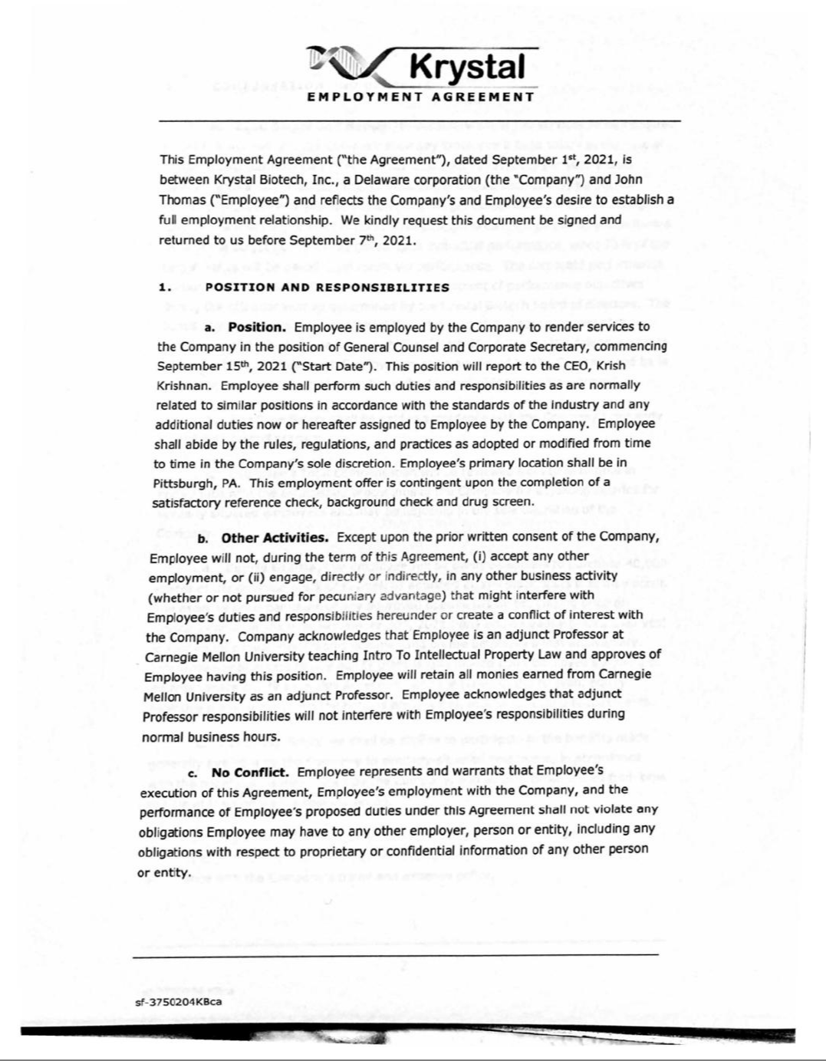

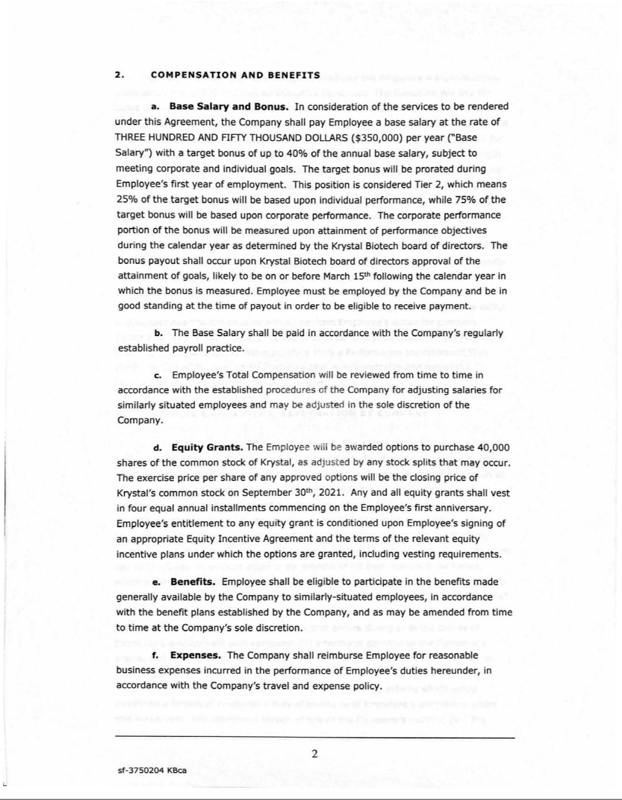

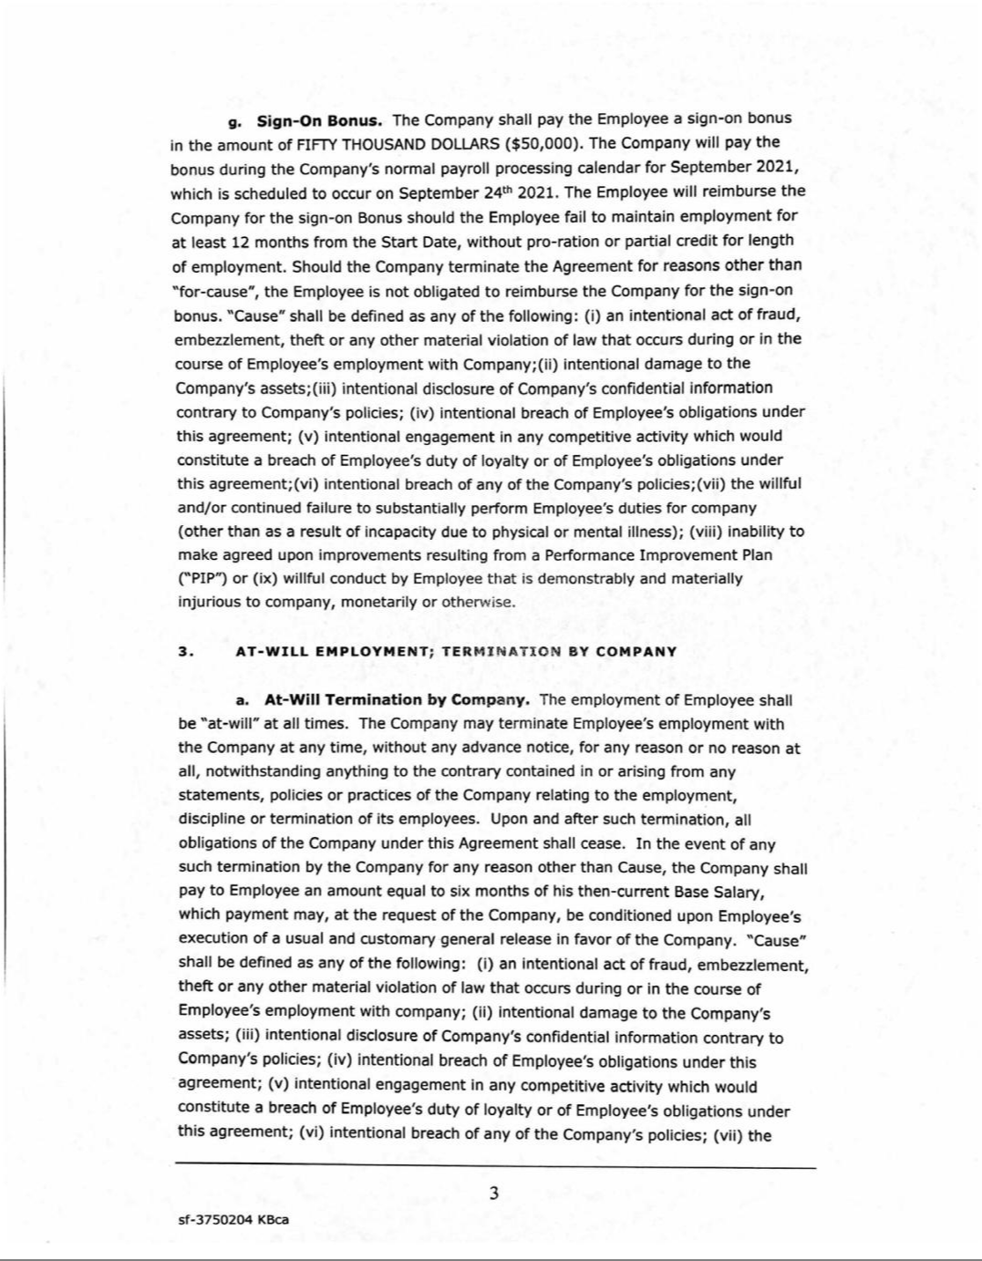

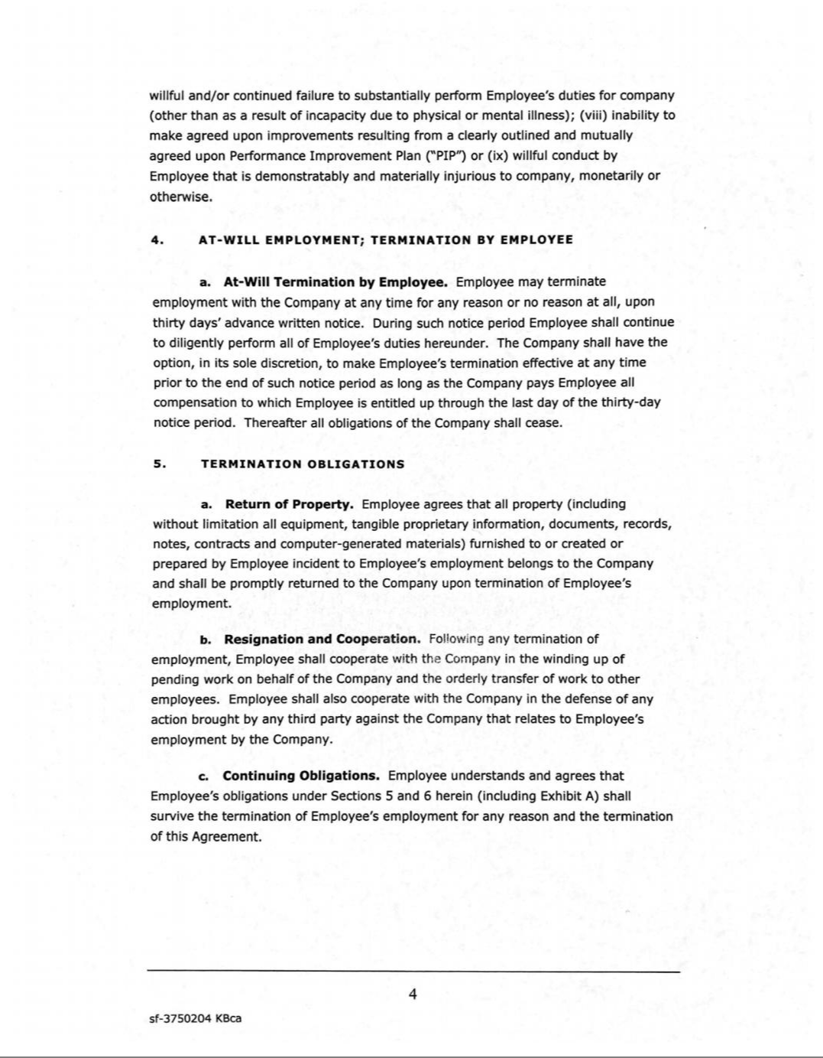

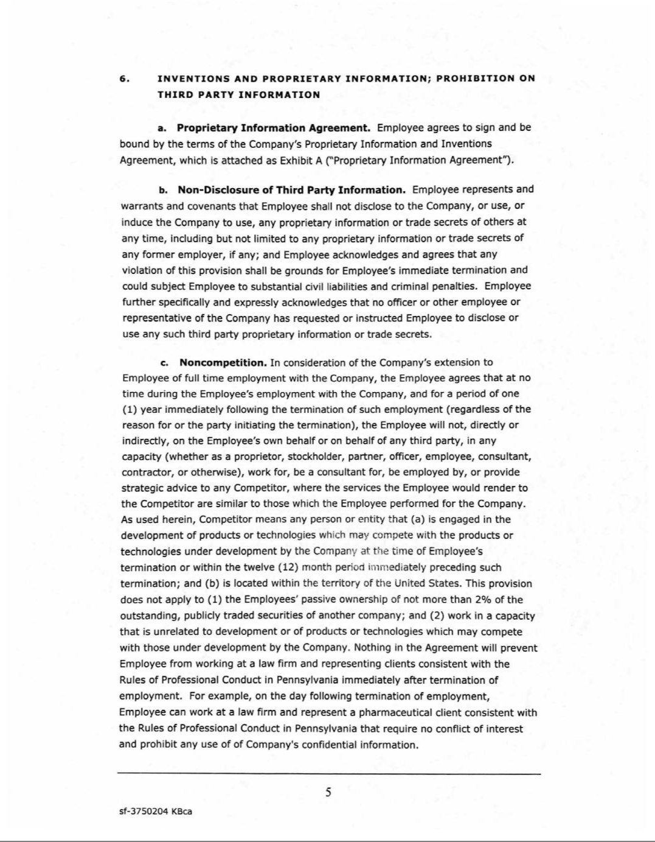

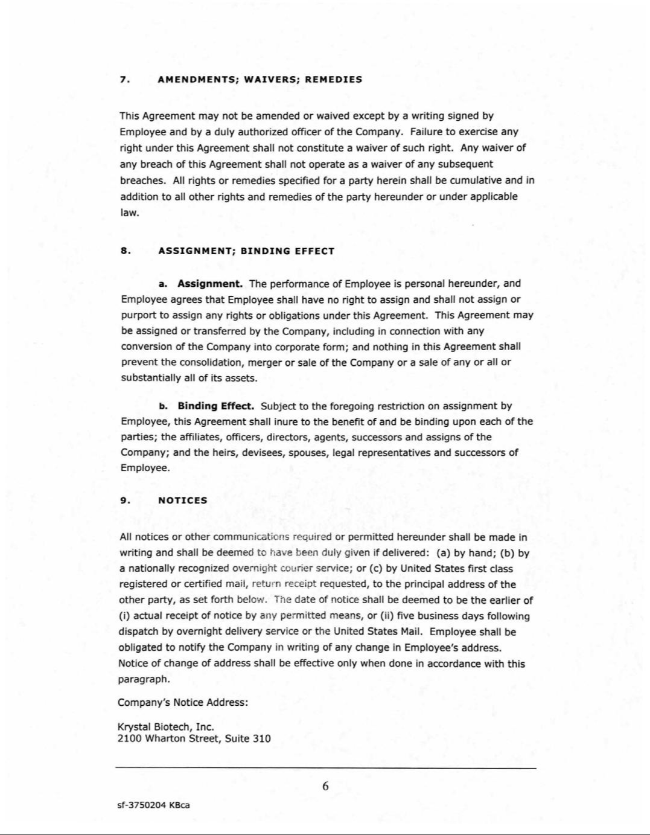

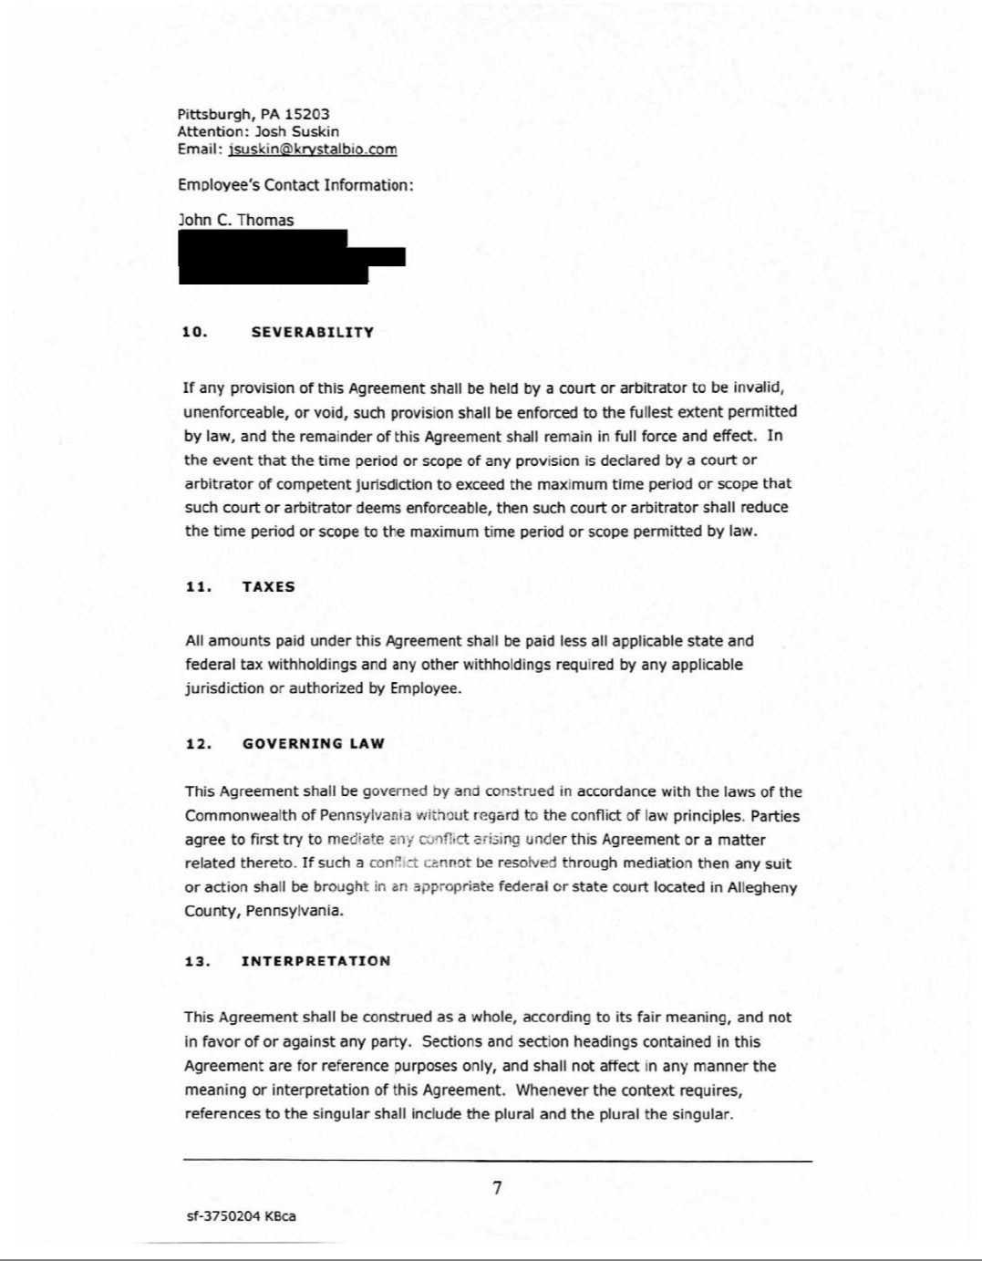

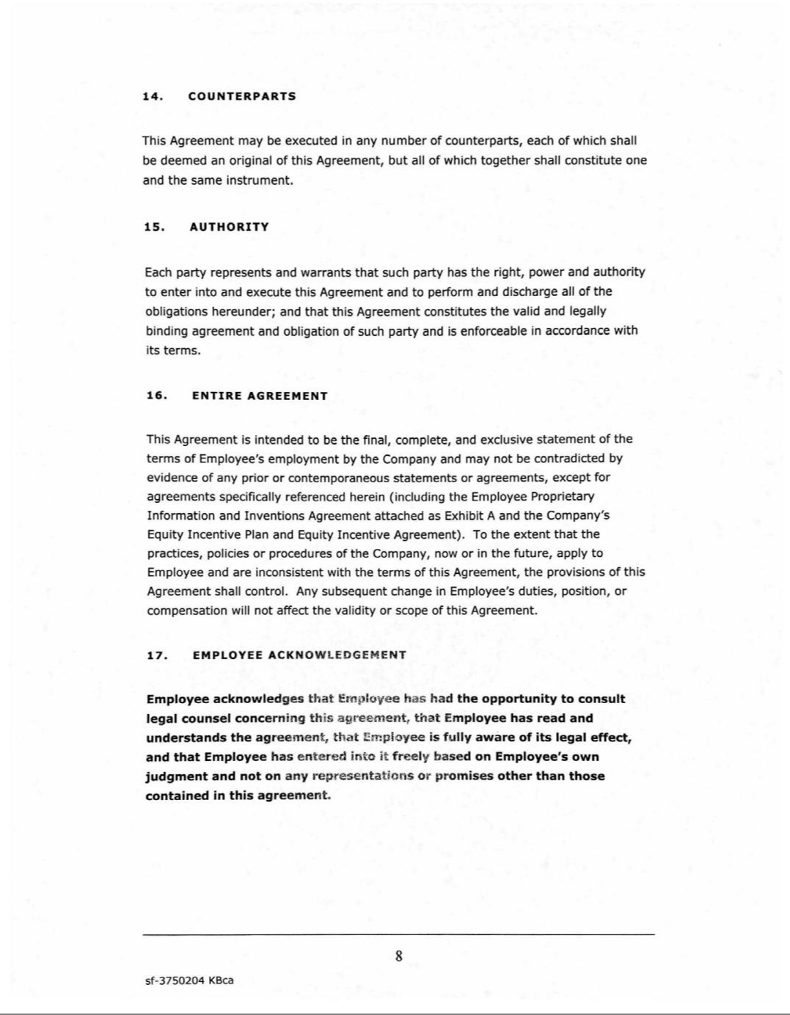

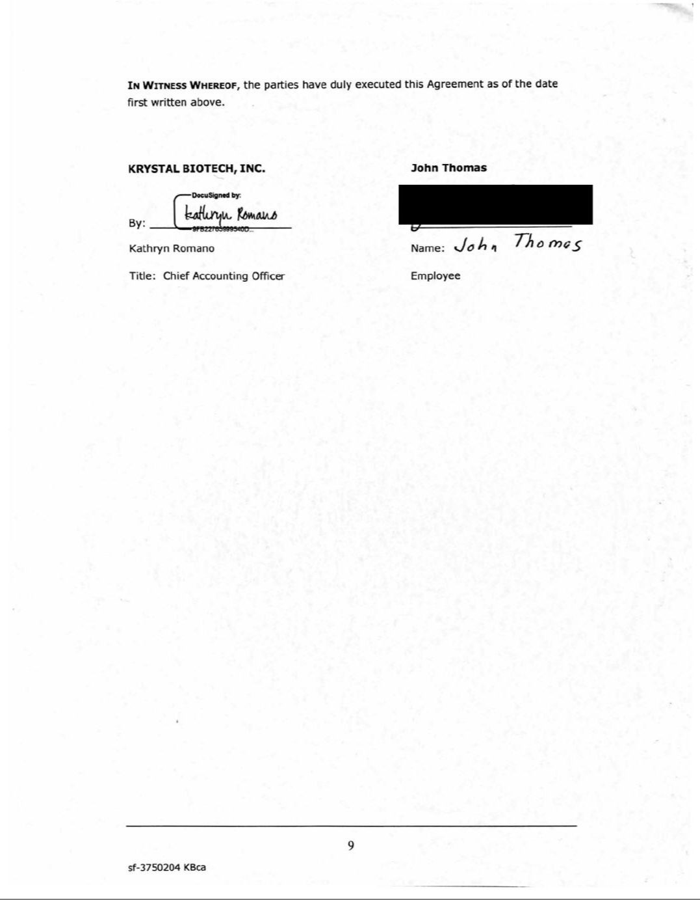

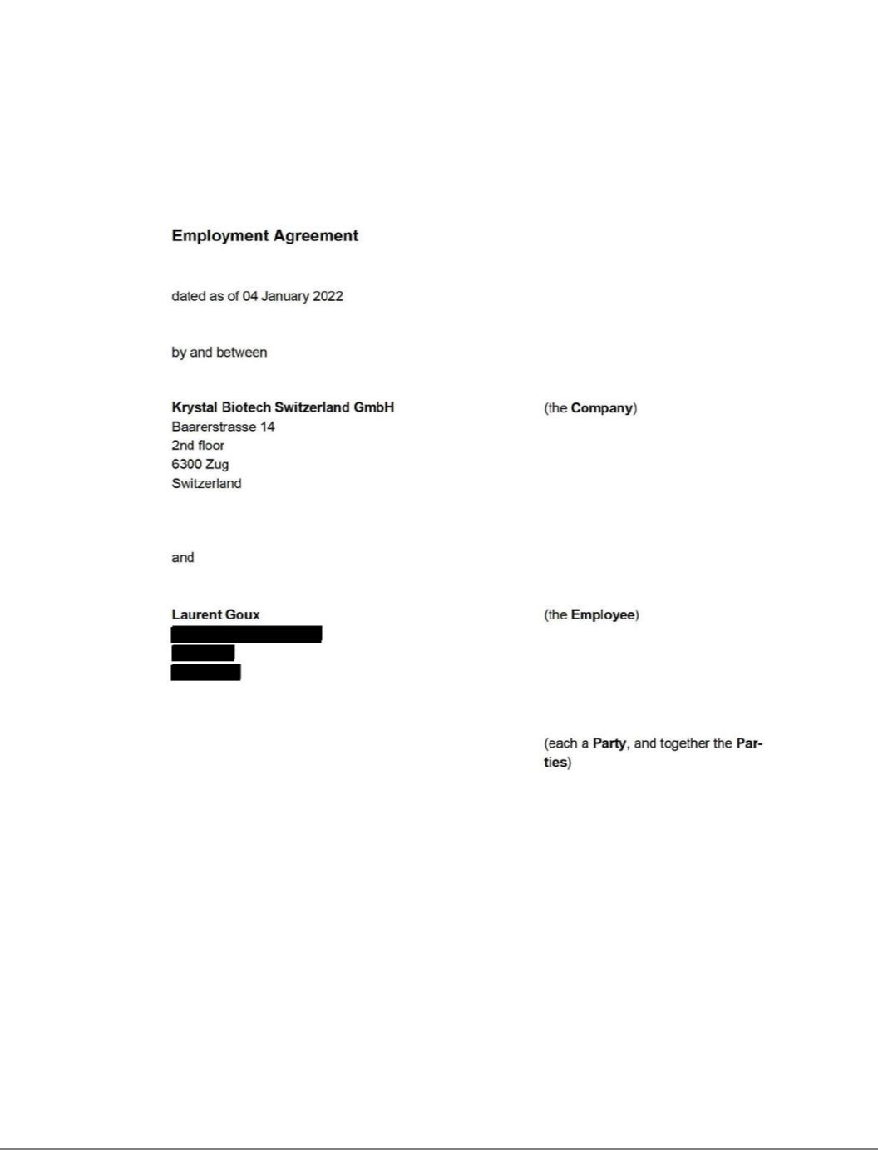

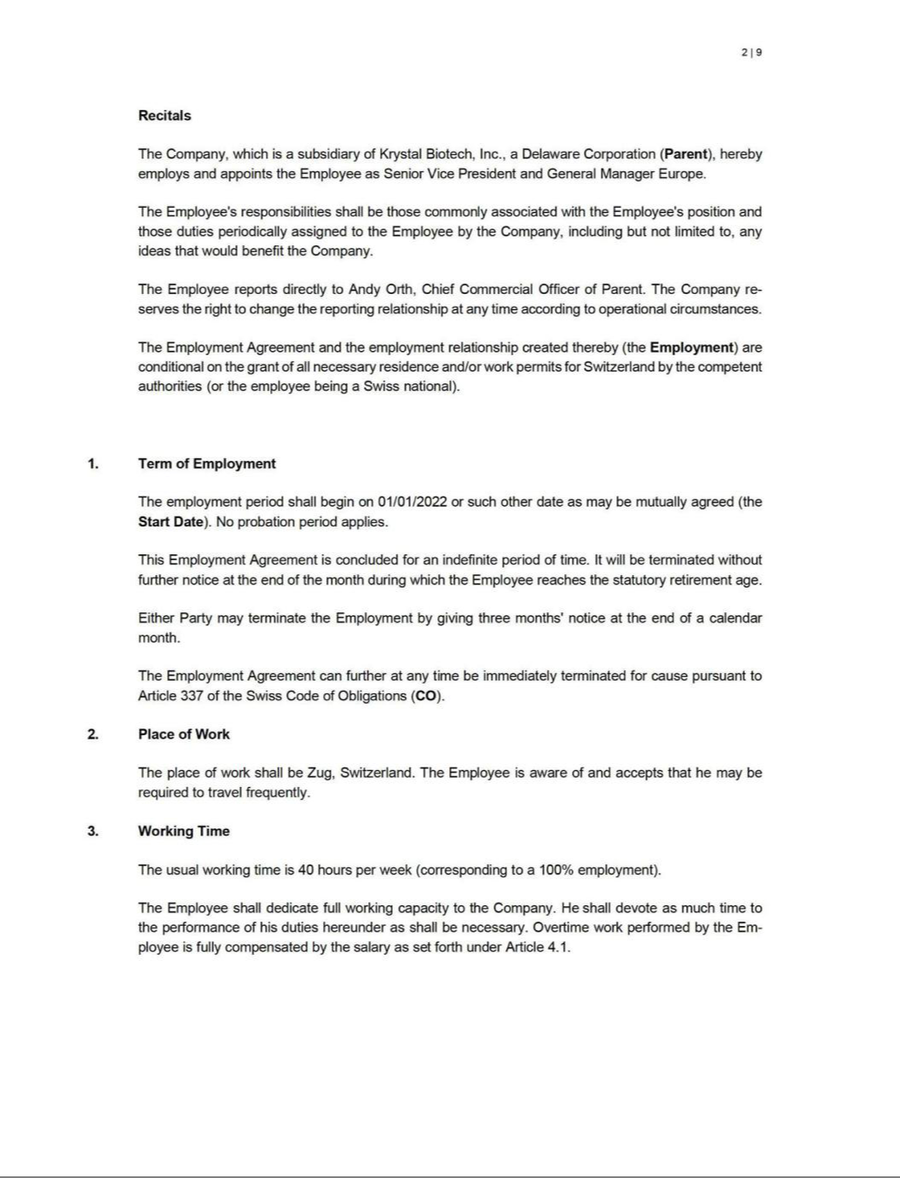

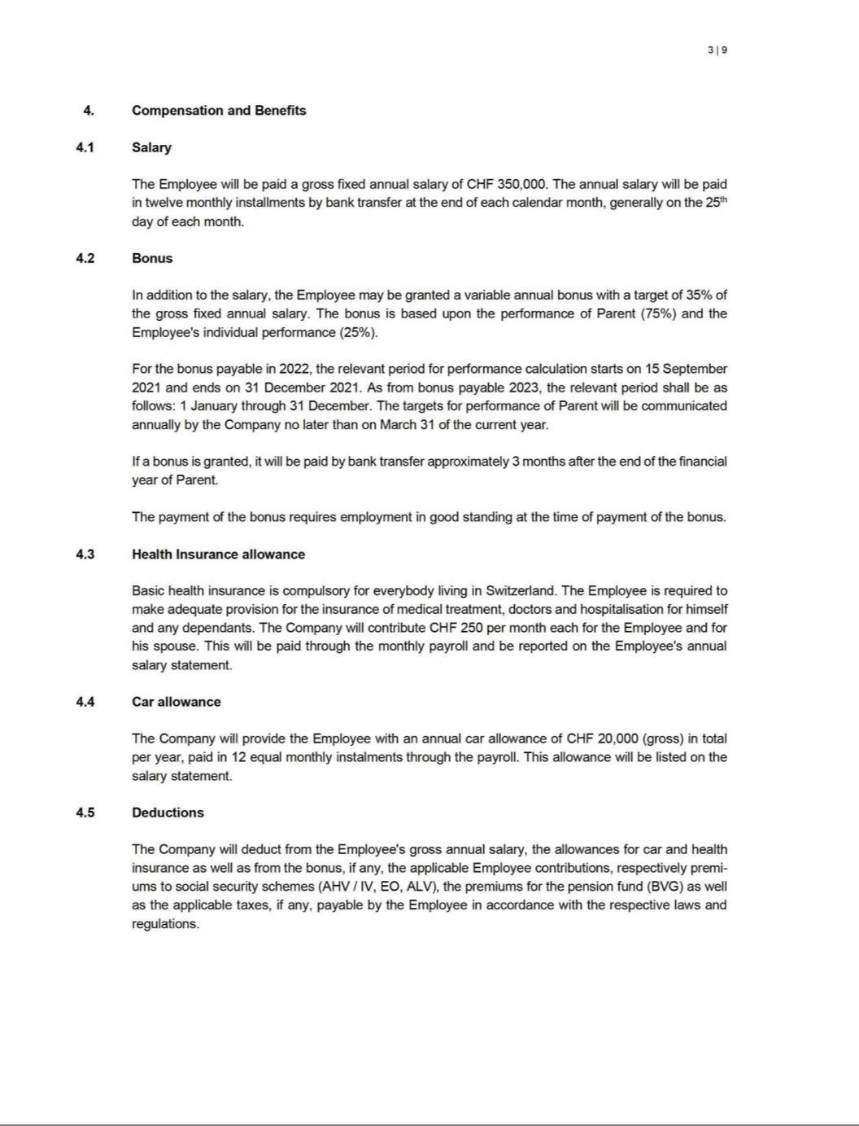

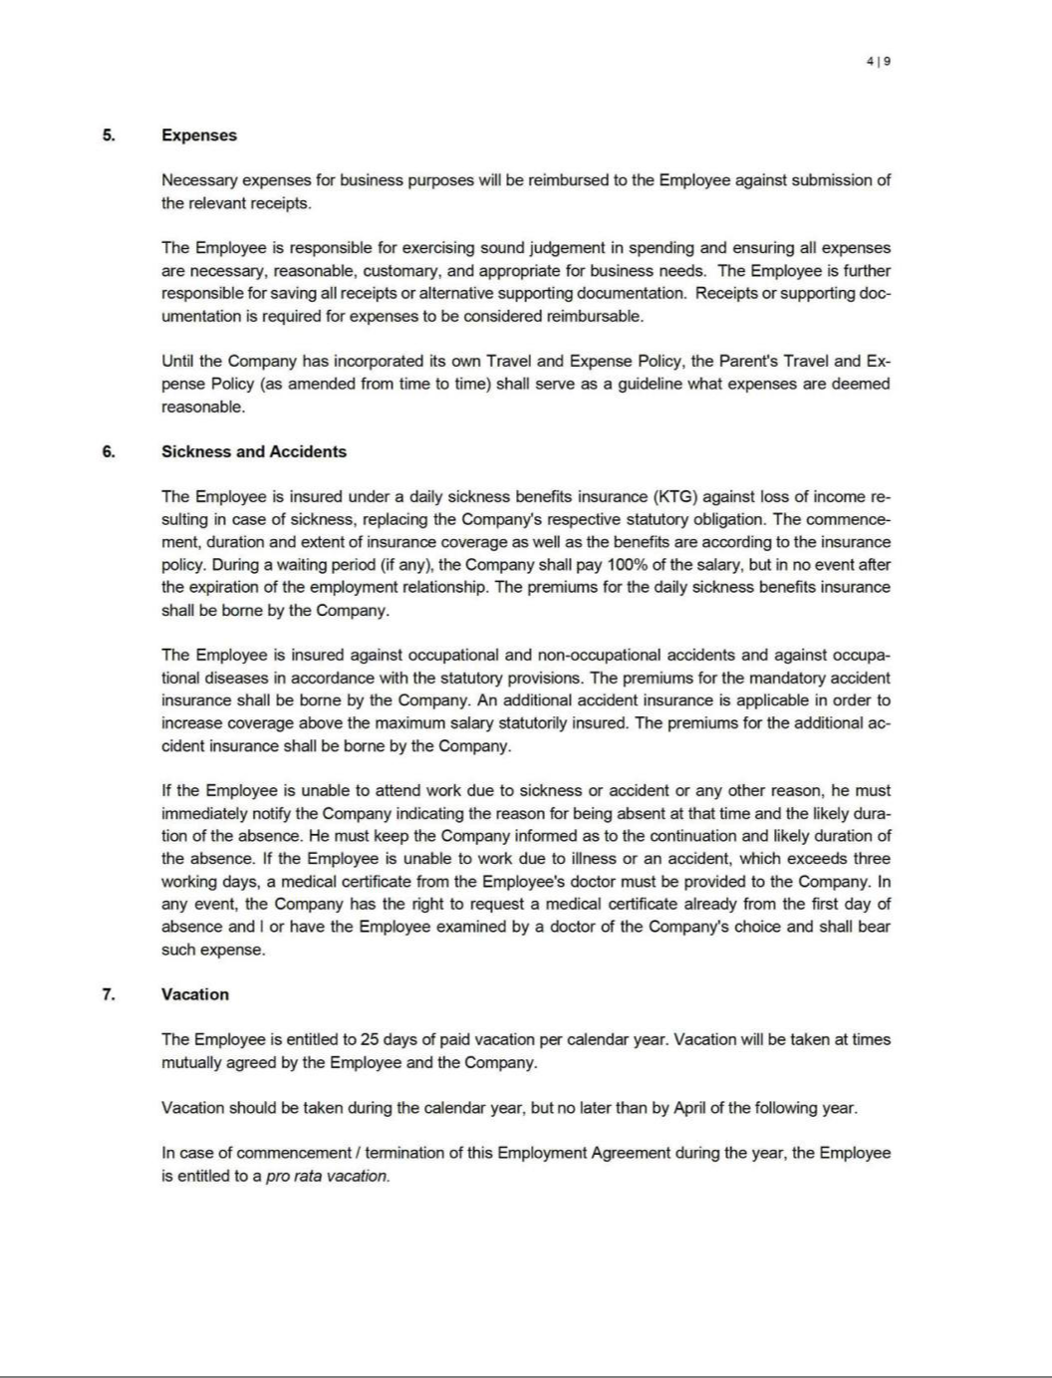

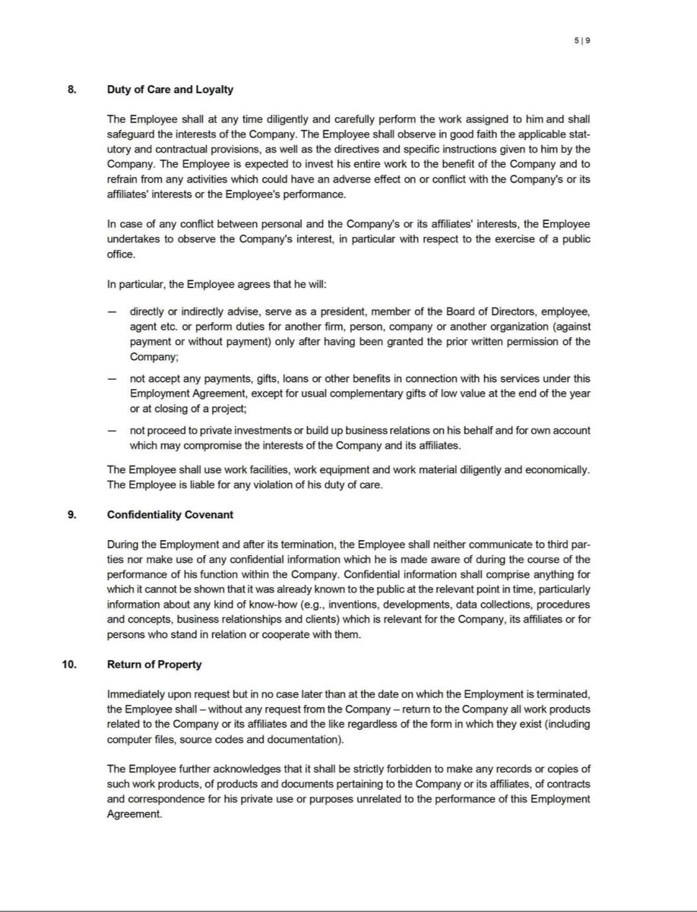

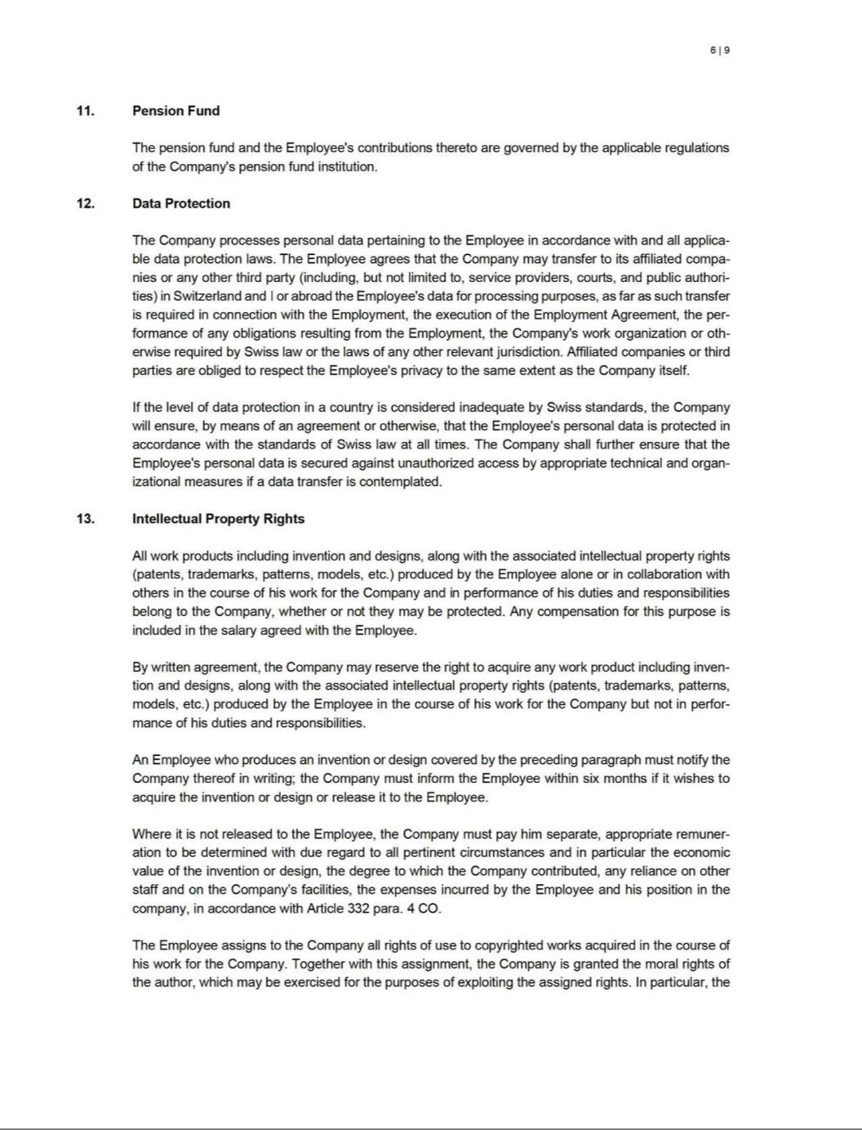

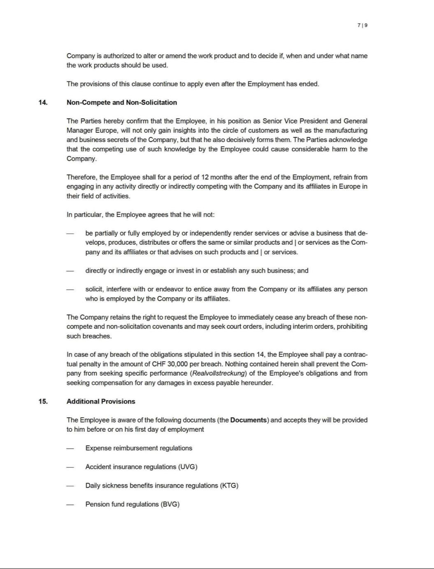

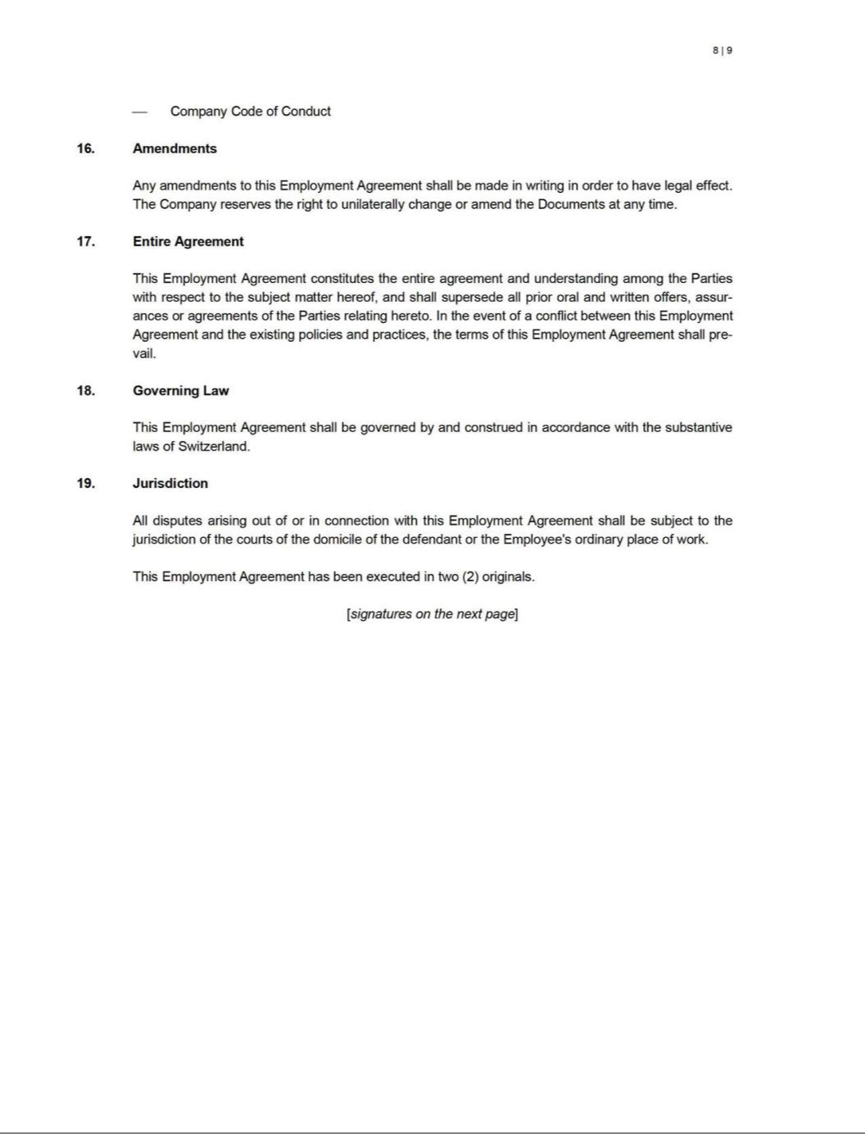

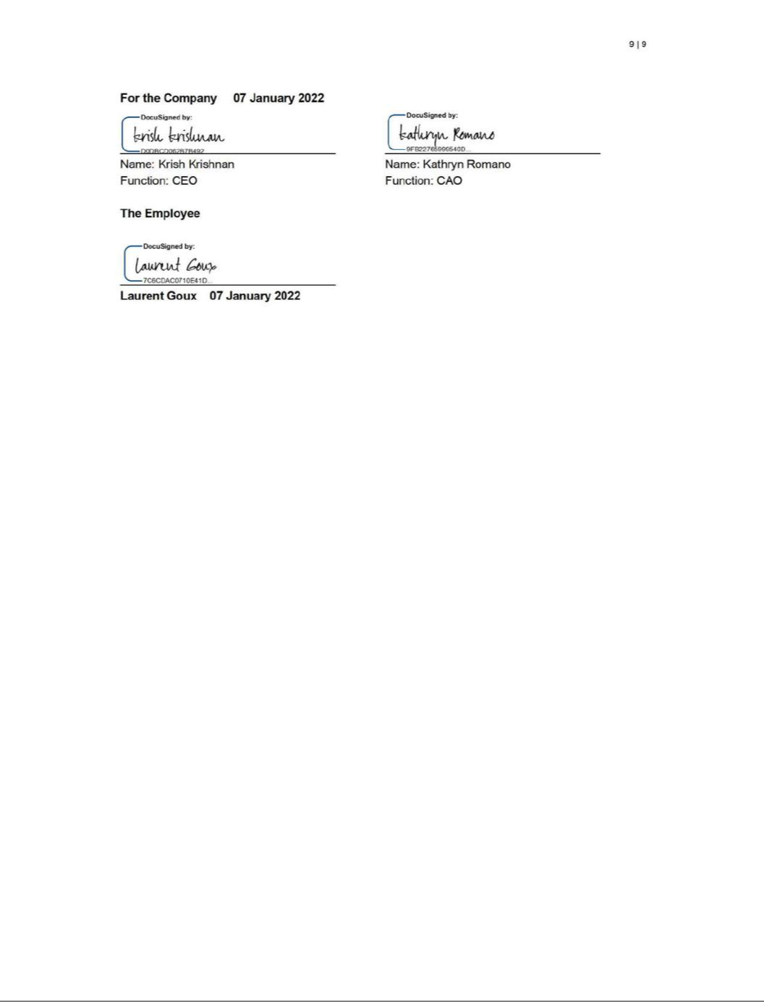

Exhibit 31.1

CERTIFICATION PURSUANT TO

RULES 13a-14(a) AND 15d-14(a) UNDER THE SECURITIES EXCHANGE ACT OF 1934,

AS ADOPTED PURSUANT TO SECTION 302 OF THE SARBANES-OXLEY ACT OF 2002

I, Krish S. Krishnan, certify that:

- I have reviewed this Quarterly Report on Form 10-Q of Krystal Biotech, Inc.;

- Based on my knowledge, this report does not contain any untrue statement of a material fact or omit to state a material fact necessary to make the statements made, in light of the circumstances under which such statements were made, not misleading with respect to the period covered by this report;

- Based on my knowledge, the financial statements, and other financial information included in this report, fairly present in all material respects the financial condition, results of operations and cash flows of the registrant as of, and for, the periods presented in this report;

- The registrant’s other certifying officer(s) and I are responsible for establishing and maintaining disclosure controls and procedures (as defined in Exchange Act Rules 13a-15(e) and 15d-15(e)) and internal control over financial reporting (as defined in Exchange Act Rules 13a-15(f) and 15d-15(f)) for the registrant and have:

  - Designed such disclosure controls and procedures, or caused such disclosure controls and procedures to be designed under our supervision, to ensure that material information relating to the registrant, including its consolidated subsidiaries, is made known to us by others within those entities, particularly during the period in which this report is being prepared;

  - Designed such internal control over financial reporting, or caused such internal control over financial reporting to be designed under our supervision, to provide reasonable assurance regarding the reliability of financial reporting and the preparation of financial statements for external purposes in accordance with generally accepted accounting principles;

  - Evaluated the effectiveness of the registrant's disclosure controls and procedures and presented in this report our conclusions about the effectiveness of the disclosure controls and procedures, as of the end of the period covered by this report based on such evaluation; and

  - Disclosed in this report any change in the registrant's internal control over financial reporting that occurred during the registrant's most recent fiscal quarter (the registrant's fourth fiscal quarter in the case of an annual report) that has materially affected, or is reasonably likely to materially affect, the registrant's internal control over financial reporting; and

- The registrant’s other certifying officer(s) and I have disclosed, based on our most recent evaluation of internal control over financial reporting, to the registrant’s auditors and the audit committee of the registrant’s board of directors (or persons performing the equivalent functions):

  - All significant deficiencies and material weaknesses in the design or operation of internal control over financial reporting which are reasonably likely to adversely affect the registrant’s ability to record, process, summarize and report financial information; and

  - Any fraud, whether or not material, that involves management or other employees who have a significant role in the registrant’s internal control over financial reporting.

Date: May 4, 2026 | By: | /s/ Krish S. Krishnan
 |  | Krish S. Krishnan
 |  | President and Chief Executive Officer

Exhibit 31.2

CERTIFICATION PURSUANT TO

RULES 13a-14(a) AND 15d-14(a) UNDER THE SECURITIES EXCHANGE ACT OF 1934,

AS ADOPTED PURSUANT TO SECTION 302 OF THE SARBANES-OXLEY ACT OF 2002

I, Kathryn A. Romano, certify that:

- I have reviewed this Quarterly Report on Form 10-Q of Krystal Biotech, Inc.;

- Based on my knowledge, this report does not contain any untrue statement of a material fact or omit to state a material fact necessary to make the statements made, in light of the circumstances under which such statements were made, not misleading with respect to the period covered by this report;

- Based on my knowledge, the financial statements, and other financial information included in this report, fairly present in all material respects the financial condition, results of operations and cash flows of the registrant as of, and for, the periods presented in this report;

- The registrant’s other certifying officer(s) and I are responsible for establishing and maintaining disclosure controls and procedures (as defined in Exchange Act Rules 13a-15(e) and 15d-15(e)) and internal control over financial reporting (as defined in Exchange Act Rules 13a-15(f) and 15d-15(f)) for the registrant and have:

  - Designed such disclosure controls and procedures, or caused such disclosure controls and procedures to be designed under our supervision, to ensure that material information relating to the registrant, including its consolidated subsidiaries, is made known to us by others within those entities, particularly during the period in which this report is being prepared;

  - Designed such internal control over financial reporting, or caused such internal control over financial reporting to be designed under our supervision, to provide reasonable assurance regarding the reliability of financial reporting and the preparation of financial statements for external purposes in accordance with generally accepted accounting principles;

  - Evaluated the effectiveness of the registrant's disclosure controls and procedures and presented in this report our conclusions about the effectiveness of the disclosure controls and procedures, as of the end of the period covered by this report based on such evaluation; and

  - Disclosed in this report any change in the registrant's internal control over financial reporting that occurred during the registrant's most recent fiscal quarter (the registrant's fourth fiscal quarter in the case of an annual report) that has materially affected, or is reasonably likely to materially affect, the registrant's internal control over financial reporting; and

- The registrant’s other certifying officer(s) and I have disclosed, based on our most recent evaluation of internal control over financial reporting, to the registrant’s auditors and the audit committee of the registrant’s board of directors (or persons performing the equivalent functions):

  - All significant deficiencies and material weaknesses in the design or operation of internal control over financial reporting which are reasonably likely to adversely affect the registrant’s ability to record, process, summarize and report financial information; and

  - Any fraud, whether or not material, that involves management or other employees who have a significant role in the registrant’s internal control over financial reporting.

Date: May 4, 2026 | By: | /s/ Kathryn A. Romano
 |  | Kathryn A. Romano
 |  | Chief Accounting Officer

Exhibit 32.1

CERTIFICATION OF CHIEF EXECUTIVE OFFICER AND CHIEF ACCOUNTING OFFICER

PURSUANT TO

18 U.S.C. SECTION 1350,

AS ADOPTED PURSUANT TO

SECTION 906 OF THE SARBANES-OXLEY ACT OF 2002

I, Krish S. Krishnan, Chief Executive Officer, certify, pursuant to 18 U.S.C. Section 1350, as adopted pursuant to Section 906 of the Sarbanes-Oxley Act of 2002, that:

- the Quarterly Report on Form 10-Q for the three months ended March 31, 2026, (the “ Periodic Report”) fully complies with the requirements of Section 13(a) or 15(d) of the Securities Exchange Act of 1934; and

- information contained in the Periodic Report fairly presents, in all material respects, the financial condition and results of operations of Krystal Biotech, Inc.

Date: May 4, 2026 | By: | /s/ Krish S. Krishnan
 |  | Krish S. Krishnan
 |  | President and Chief Executive Officer

I, Kathryn A. Romano, Chief Accounting Officer, certify, pursuant to 18 U.S.C. Section 1350, as adopted pursuant to Section 906 of the Sarbanes-Oxley Act of 2002, that:

- the Quarterly Report on Form 10-Q for the three months ended March 31, 2026, (the “ Periodic Report”) fully complies with the requirements of Section 13(a) or 15(d) of the Securities Exchange Act of 1934; and

- information contained in the Periodic Report fairly presents, in all material respects, the financial condition and results of operations of Krystal Biotech, Inc.

Date: May 4, 2026 | By: | /s/ Kathryn A. Romano
 |  | Kathryn A. Romano
 |  | Chief Accounting Officer

